CM2020: Agile Software Projects

“To-Do Application”
A productivity app to help people with planning and accomplishing their tasks

TEAM 82

Authors:
Akhila Rao Sambangi (220628334)
Seah Zhao Xiang (220628884)
Seenivasan Siva Ranjana (220516178)
Nisha Ramprasath (220631895)
Ramu Kirubanidhi (210469394)

Table of Contents
1. Aims and Objectives 4
1.1 Introduction 4
1.2 Concept 4
1.3 Background 4
1.4 Aims and Objectives 5
2. Planning 6
2.1 Discussion about Topics 7
2.2 Brainstorming 8
2.3 Planning after Market Research 9
3. Specifications 10
System Overview 10
3.1 Architecture 10
3.2 Components 10
3.3 Workflow 11
3.4 Security 11
3.5 Scalability and Performance 11
3.6 Tools and Technologies 12
4. Scope 14
4.1 Scope 14
4.2 Limitations 14
5. Requirements 15
5.1 Stakeholders 15
5.2 Functional Requirements 15
5.3 Non-Functional Requirements 15
6. Market Research 17
6.1 Existing task management apps in the market 17
6.1.1 Todist 17
6.1.2 Apple reminder 17
6.1.3 kidstodo 18
6.1.4 OmniFocus 18
6.1.5 Google Tasks 18
6.1.6 WeNote 19
6.2 Market Research Evaluation 19
6.3 Table of comparison 20
6.4 SWOT Analysis 22
A. Strength 22
B. Weakness 22
C. Opportunities 22
D. Threats 22
6.5 STEEPLE Analysis 23
A. Social 23
B. Technology 23
C. Economic 23
D. Environment 23
E. Politics 23
F. Legal 24
G. Ethics 24
6.6 Summary 24
7. Prototyping 25
7.1 First Design 25
7.2 User feedback 26
7.3 Second Design 27
7.3.1 Second Design - High fidelity 28
8. Evaluation and Assumption Testing 35
8.1 Coming up with the concept 35
8.2 Developing the concept 36
8.3 Finalising the concept and providing the basis 36
8.4 Conducting SWOT and STEEPLE analysis 37
8.5 Model design 38
8.6 Assumption Testing 39
1. User-Centred Design 39
2. Core Functionality 39
3. Performance 39
8.7 General Evaluation 40
9. Conclusion 41
10. References 42
11. Appendices 44
11.1 Appendix: Notes and ideas from meetings 44
11.2 Appendix: First design model 49
11.3 Appendix: User feedback 54

1. Aims and Objectives

1.1 Introduction
In today's fast-paced world, staying organised is more important than ever. As individuals manage multiple tasks across different areas of their lives, an efficient task management tool is essential. This proposal aims to present a comprehensive To-Do application that streamlines task management, improves productivity, and simplifies daily duties.

1.2 Concept
The To-Do application will be a user-friendly feature-rich platform accessible through the website . It will provide basic task management functionalities such as creating, editing, adding reminders and progress monitors. Users will have the flexibility to organise tasks into lists. Key features of the Todo app will include:
- Task Management: Create, edit and delete,.
- Organisation: Group tasks into projects or categories for better organisation.
- Reminders and Notifications: Set reminders and receive notifications for upcoming tasks.
- User Authentication: Secure user accounts with login credentials and encrypted data storage.
- Can add location and images

1.3 Background
The concept of task management applications has evolved significantly over the past decade due to technological advancements and the growing demand for efficiency in both personal and professional environments. Existing applications such as Todoist, Trello, and Microsoft To Do have set the benchmark in task management with their intuitive interfaces and robust feature sets.

Our Todo app aims to build on these foundations by providing a customizable user-centric experience tailored to the specific needs of individuals and teams. By leveraging the latest web technologies and responsive design principles, the app ensures optimal performance on all devices while ensuring the security and privacy of your data through robust encryption procedures.

1.4 Aims and Objectives
The aim of the to-do app project is to create an user friendly and efficient task management tool specifically catering to the needs of the group ranging from young adults to adults. This specific target group includes students, working adults and individuals managing multiple personal and professional responsibilities. This concerned group often struggles to balance their daily tasks and commitments. Hence, our goal is to enhance productivity and organisation in their routine by providing an intuitive platform that simplifies task tracking, prioritisation, and completion.
We are building our app with the user in mind in order to do this. Through this, we can make sure that the interface is both extremely useful and aesthetically pleasing.The application will have a responsive, simple design that minimises clutter and prioritises usability.This makes it simple and quick for users to add, organise, and manage their assignments. The main features will be the ability to prioritise activities, establish deadlines, mark significant jobs with flags, and categorise work.These are essential for managing tasks effectively.
In order to assist users in staying on target and avoiding task misses, we also intend to include tools like notifications and reminders.We intend to lessen users' cognitive burden by incorporating these features, freeing them up to concentrate more on task execution rather than task memorisation. For young adults and adults who must balance a variety of obligations, including employment, school, and personal projects, this is extremely important.
In addition to task management, our software will assist users in setting objectives and monitoring their progress so they can recognize their accomplishments and maintain motivation. The purpose of this function is to promote continuous production and a sense of accomplishment. The app can assist users in identifying areas for improvement and forming better time management habits by displaying tasks as they are completed.
In addition, we want to develop a social element in the app so that users may communicate with friends and coworkers about their progress and goals. This can offer a network of support and encourage accountability.This improves the user experience in general and allows them to receive feedback from their peers as well.This feature, in our opinion, sets our software apart.
In summary, our app seeks to assist users in leading more stress-free, balanced lives and enhancing their time management abilities. Our aim is to provide a tool that will assist young persons and adults in maintaining their organisation skills and advancing professionally.

2. Planning
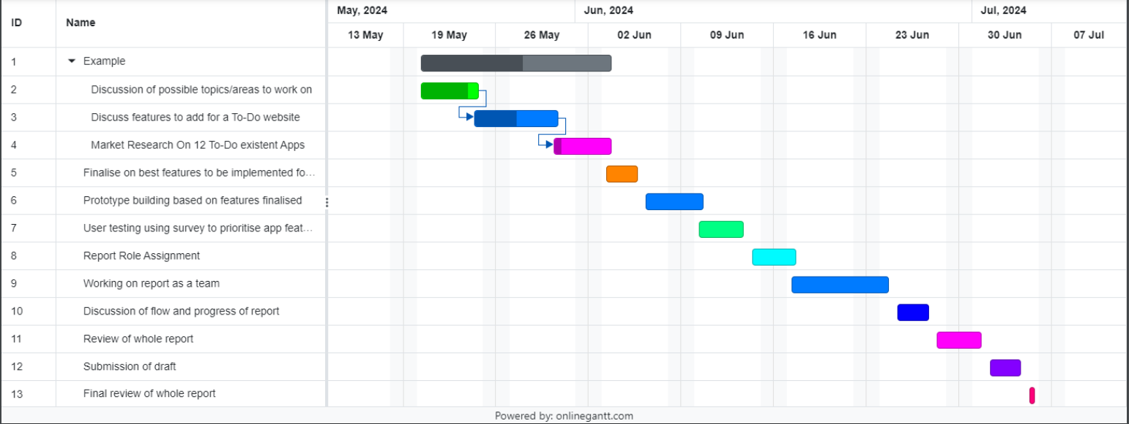
Figure 1: Gantt chart with the plan of action for the project

The initial Gantt chart outlined our plan to follow up with the mid-term report. However, we encountered challenges along the way that prevented us from sticking to the schedule entirely. Despite this, we set realistic goals for our team. For example, we conducted a survey to identify features preferred by potential users. Gathering sufficient responses took longer than anticipated, which delayed our ability to analyse the results and incorporate our findings into the prototypes. Another challenge was that different group members worked on various parts of the report, leading to a lack of flow. As a result, it took more time than expected to review and revise the report to ensure a smooth and consistent flow.

2.1 Discussion about Topics
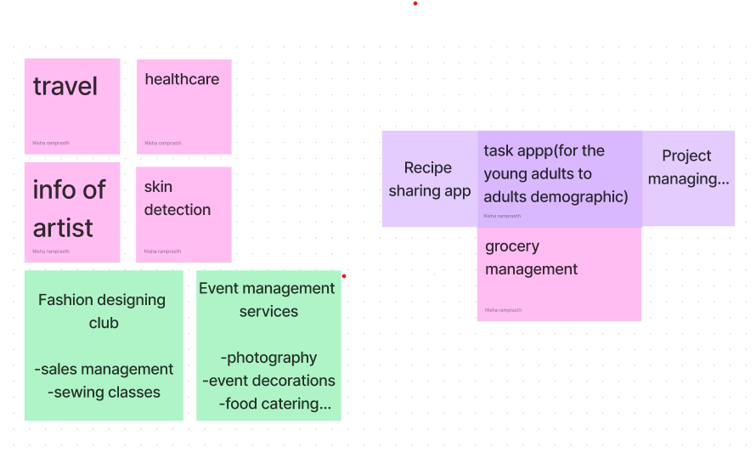
Figure 2: Brainstorming ideas for the project

At the start of our planning process, our group had an extensive discussion about selecting the most favourable topic for our project. We considered various ideas, including travel, healthcare, event management, a recipe-sharing app, task management, project management, and grocery management. After evaluating each option, we decided to focus on developing a task app tailored for young adults to adults. As a group of young students, we felt we could empathise with the daily busy lives of individuals in our age group. We believed this perspective would help us create an app that genuinely addresses the needs and challenges of our peers. Additionally, we wanted to focus on a project that was straightforward, purposeful, and aimed at reducing clutter in users' lives. This approach would help us achieve a clear and efficient final product, ensuring that the app would be practical and valuable for its intended users. Our decision was driven by a desire to create something that would make a real difference in helping people manage their daily tasks more effectively.

2.2 Brainstorming
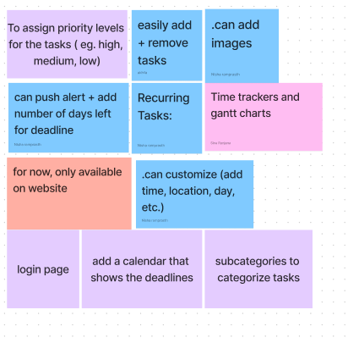
Figure 3: Brainstorming features for application
Subsequently, our group discussed the potential features we would like our final to-do app to include. We started by listing the general features that a to-do app would typically have, such as push notifications, recurring tasks, the ability to add images, a calendar to display deadlines, creating subcategories to organise tasks, and a login page for user authentication. Our aim was to brainstorm broadly before conducting market research, which would allow us to refine our ideas. During this research, we planned to identify which features might pose security risks and should therefore be removed. At the same time, we wanted to ensure that we retained the essential features that form the core functionality of a productivity app. Our goal was to balance innovation with practicality, ensuring our app would be both useful and secure. This thorough planning process would help us create an app that genuinely enhances productivity while addressing the real needs and concerns of our target audience.

2.3 Planning after Market Research

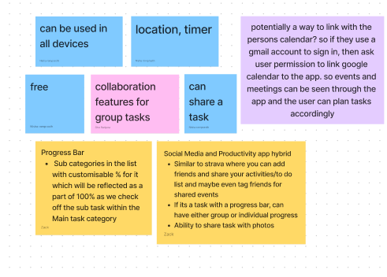
Figure 4: Planning after market research

Next, as detailed in our Gantt chart, our group conducted market research on 6 to-do apps. This research enlightened us with features such as group collaboration and cross-platform compatibility for both iOS and Android, emphasising the need to be broad and inclusive. We also discovered a feature that allows Google Tasks to sync with Google Calendar, which initially caught our attention. However, we decided against implementing this due to potential security risks.
Some of the features mentioned in the image were thoughtfully conceptualised by us. We conducted user surveys and discovered that many users find productivity apps boring, which discourages regular use. This insight led us to develop a progress bar that checks off subtasks within the main task category, increasing the percentage of work completed. We believed this feature would provide motivation to users by offering a visual representation of their progress, instilling a sense of hope and accomplishment. Additionally, we aimed to introduce a social element to our app, making it more engaging. Users would be able to share their tasks with close ones, providing an extra layer of motivation and making the app more exciting and interactive.Subsequently , we moved on to building on our prototype based on the features we finalised for our app. Following that , we conducted user testing using surveys to come up with our final prototype. Final steps were followed exactly as what was mentioned in the gantt chart above.

3. Specifications

System Overview

3.1 Architecture
The To-Do List Productivity App will follow a three-tier architecture consisting of the presentation layer, application layer, and data layer. This modular approach ensures scalability, maintainability, and efficient development.

Presentation Layer: This is the front-end of the application where users interact with the app. It includes the user interface (UI) and handles user input. Technologies used include HTML, CSS, and JavaScript with a front-end framework like React.

Application Layer: This middle layer contains the business logic and handles the communication between the presentation and data layers. It is implemented using Node.js and Express.js to manage user requests, perform operations, and apply business rules.

Data Layer: This back-end layer is responsible for data storage and management. It uses a database management system (DBMS) such as MongoDB to store user data, task details, and other relevant information.

3.2 Components
User Interface (UI):
1. Sign Up/Login Page:
· Allows users to create accounts and authenticate.
· Dashboard: Displays an overview of tasks, including due tasks, upcoming tasks, and completed tasks.
· Task Management: Pages for creating, editing, and deleting tasks.
· Settings: Allows users to configure preferences such as notification settings and profile information.

2. API Endpoints:
· Authentication: Endpoints for user registration, login, and logout.
· Task Management: Endpoints to create, read, update, and delete tasks.
· User Management: Endpoints to manage user profiles and settings.

3. Database:
· Users Collection: Stores user credentials and profile information.
· Tasks Collection: Stores task details, including titles, descriptions, deadlines, priorities, and completion status.
· Settings Collection: Stores user-specific settings such as notification preferences.

3.3 Workflow
1.User Registration and Authentication:
· A new user registers through the sign-up page.
· User credentials are securely stored in the database.
· Registered users can log in using their credentials.

2.Task Creation and Management:
· Users log in and access their dashboard.
· Users can create new tasks by entering details such as title, description, deadline, and priority.
· Tasks are stored in the database and displayed on the dashboard.
· Users can edit or delete tasks as needed.

3.Notification System:
· The app checks for upcoming deadlines and sends reminders based on user preferences.
· Notifications are displayed within the app and/or sent via email or push notifications, depending on user settings.

3.4 Security
· Authentication: Uses JWT (JSON Web Tokens) for secure user sessions.
· Data Encryption: Sensitive data, such as passwords, are encrypted before storage.
· Secure Communication: Uses HTTPS for secure data transmission between the client and server.

3.5 Scalability and Performance
· Load Balancing: Distributes incoming traffic across multiple servers to ensure high availability and reliability.
· Database Indexing: Optimizes database queries for faster data retrieval.
· Caching: Uses caching mechanisms to reduce server load and improve response times.

3.6 Tools and Technologies
· Front-end: React, HTML, CSS, JavaScript
· Back-end: Node.js, Express.js
· Database: MongoDB
· Version Control: Git/GitHub
· Deployment: Docker, Kubernetes, and cloud services like AWS or Heroku

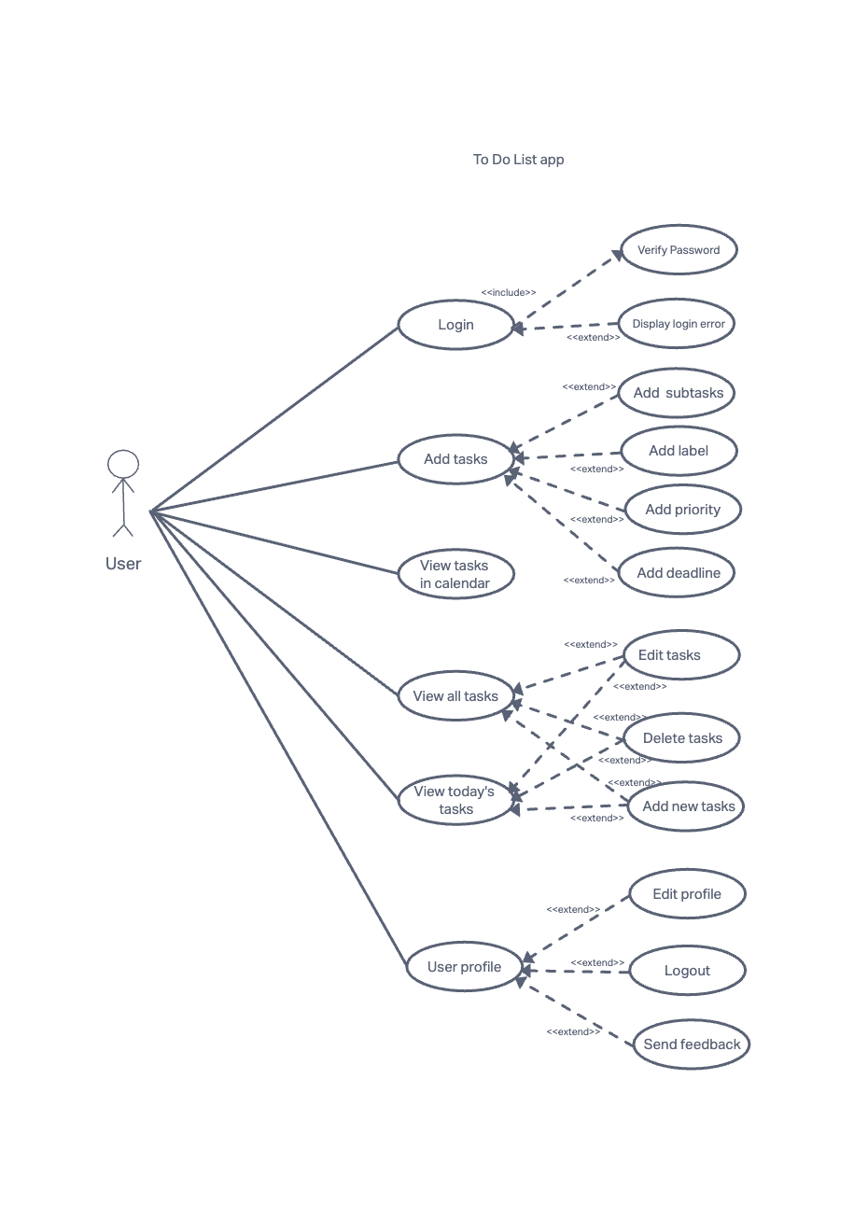
Figure 5: Use case diagram

4. Scope

4.1 Scope
Our app's distinctive feature would be a social component that enables users to post their assignments and accomplishments on social media. The purpose of this feature is to motivate users, create a sense of community and promote accountability. Through the utilisation of social sharing, individuals can commemorate their achievements, look for motivation and also motivate others.
Advanced features like goal-setting, progress tracking, and notifications are something we intend to include. We will be incorporating a task completion bar, which shows the status of each job graphically.This will be a crucial component of the app as this feature encourages users to finish their work on time by giving them a clear and encouraging visual indicator of their progress, which helps them stay on track.
Additionally, the app will have an easy-to-use layout that prioritises the needs of our primary target group while simultaneously catering to a wide range of customers. We will ensure a user-centric approach by using survey responses from potential users to guide our design and functionality decisions.

4.2 Limitations
Although our to-do app is very extensive, it is not without limitations. The choice to exclude elements that facilitate team cooperation is one major drawback. This decision was made due to worries about possible security threats that could arise from distributing sensitive task information among several users. Strong security protocols to facilitate teamwork would be resource-intensive and would bring vulnerabilities that we are not yet equipped to handle.
Furthermore, even while the app is meant to be user-friendly and accessible, it might not adequately address the unique requirements of every demographic group, including kids and the elderly. Since young adults and adults continue to be our main focus, some features might not be as helpful or understandable for other age groups.
To sum up, our software seeks to offer a robust, easy-to-use work management solution with a significant social component, while being conscious of its limits with regard to demographic targeting and team collaboration.

5. Requirements

5.1 Stakeholders
Our project involves several key stakeholders who are vital to its success. The primary stakeholders are our target users: young adults and adults, including students and working professionals. These individuals need an efficient task management solution to help them balance various responsibilities. While the app is designed with this demographic in mind, it remains inclusive, allowing other groups like kids and the elderly to use it as well, although the features are more tailored to the needs of young adults and adults.
We have actively included prospective users in the development process. We conducted a survey targeting young individuals to learn more about their preferences for features in to-do apps. This survey provided insights into which features users like and dislike in existing to-do applications. The input we received from this survey is invaluable, as it helps us make informed decisions about the features and design of our app, ensuring it truly caters to the requirements and preferences of our target user base.
Our goal is to develop a task management application that benefits a wider range of users by improving efficiency and organisation. We plan to achieve this by focusing on these stakeholders, including our survey respondents. Below are a lists of functional and non-functional requirements we have come up with after considering the stakeholders.

5.2 Functional Requirements
- User Authentication: Users can create accounts and log in securely.
- Task Management: Users can create, edit, and delete tasks.
- Priority and Deadlines: Users can assign priorities and deadlines to tasks.
- Reminders: Users receive notifications for upcoming deadlines.
- Search and Filter: Users can search for tasks and filter by priority or deadline.

5.3 Non-Functional Requirements
- Usability: The app must be easy to navigate and user-friendly.
- Performance: The app should load tasks quickly and handle multiple users efficiently.
- Security: User data must be securely stored and transmitted.
- Scalability: The app should handle growing user data and concurrent users.

6. Market Research
In our market research, we explored a wide range of task management applications to understand their strengths and weaknesses. Here is a detailed analysis of the most commonly used task management apps, with their unique features and cons.

6.1 Existing task management apps in the market

6.1.1 Todist
Todoist is a versatile task management application that will allow users to create sub-projects for better task organisation within specific projects. It supports team collaboration by allowing users to invite team members to work together, view each other’s tasks, and delegate responsibilities as needed. The app features several tabs to organise tasks: the Inbox for immediate task capture, Today for tasks due that day, Filters and Labels for sorting and prioritising, and Upcoming for viewing tasks for the week ahead, with options to display tasks as a list or board. Adding tasks is simple, with functionalities to prioritise, label, and set due dates to ensure timely completion. Todoist also supports extensions for additional features. However, some features are locked behind a $48 annual subscription, and the app only allows users to select the day for tasks, not specific times

6.1.2 Apple reminder
Apple Reminders is a detailed and minimised task management app that offers a user-friendly interface, making it easy to use. It allows users to share to-do lists and assign tasks, which facilitates collaboration. Users can create alerts for tasks and receive notifications across all Apple devices, including iPhone, Mac, and iPad. The app supports push notifications before events, can repeat events, and allows users to add images to tasks. Integration with Siri for voice commands further enhances its functionality.

However, Apple Reminders has some drawbacks. It does not display missed tasks separately; instead, they are added to the normal list without specific alerts on iPhones and Macs, which could lead to important tasks being overlooked. Additionally, some functions can be difficult to find, making navigation challenging at times. The app also has cross-platform limitations, as it is only usable within the Apple ecosystem. Users may experience occasional syncing issues with other devices, which can disrupt task management.

6.1.3 kidstodo
It is a To-Do List that stands out as a user-friendly task management app specifically designed for children, catering to a wide range of ages, including those with ADHD and autism. It serves as an ideal tool for children with special needs, providing a visual schedule that aids in transitioning between activities smoothly. The app offers a clutter-free experience with no ads and no in-app purchases, ensuring a safe and focused environment for young users.

However, KidsTODOList has notable drawbacks that affect its usability. Firstly, it lacks alarms to notify users when tasks should start or end, which could hinder maintaining a structured routine. Additionally, the requirement to hold down a button for the timer to run before accessing any screen function can be cumbersome and counterintuitive. Furthermore, the absence of a daily reset feature makes it difficult for users to effectively organise and manage their schedules on a daily basis, potentially limiting its practicality for ongoing use.

6.1.4 OmniFocus
OmniFocus provides a personalised task management experience with a user version that requires signing in, ensuring secure access to tasks. It excels in synchronising tasks across multiple devices, enabling users to manage their tasks seamlessly from anywhere. The app's ability to link tasks to the user's phone calendar enhances organisation and integration into daily schedules. However, OmniFocus is a paid application, which may deter users seeking free alternatives for task management.

6.1.5 Google Tasks
Google Tasks is appreciated for its well-organised and intuitive layout, featuring clear sections like "Hobby" and "Study" that allow users to categorise tasks effectively. This structure facilitates the addition of reminders under appropriate headers, enhancing overall organisation and task management. Users benefit from basic task management capabilities, such as breaking down large tasks into manageable subtasks, which improves productivity by providing a detailed approach to task completion. The app's availability on both android, ios, and web platforms ensures seamless task management across devices, offering a unified experience. Integration with Google Calendar further enhances its utility, automatically syncing tasks created in the calendar to Google Tasks, which streamlines task management and reduces the need for switching between apps.

However, Google Tasks has several limitations. It lacks detailed reporting and time tracking features crucial for analysing task completion rates and optimising productivity. The absence of robust collaboration tools makes it less suitable for team-based projects and complex project management needs. Additionally, the app's limited customization options, such as the inability to include rich text formatting or attachments like images, may restrict its flexibility and appeal, particularly for users, including children, who benefit from visual aids in task management.

6.1.6 WeNote
WeNote offers an intuitive interface with simple layouts, allowing users to quickly create notes, to-do lists, and reminders without a steep learning curve. The app supports colour customizations for notes, labels, and to-do lists, which aids in organising tasks visually. It operates fully offline, ensuring reliable access to notes and tasks without an internet connection. Users can enhance their notes with multimedia elements like pictures, audio recordings, and drawings, providing a versatile approach to note-taking.

However, there were many features such as adding drawings, recordings, and custom themes that required a premium subscription. The free version includes advertisements, which may be distracting for some users. The cost of the premium subscription is considered high compared to similar apps. WeNote lacks advanced task management features such as project tracking and team collaboration tools. Additionally, it is available only on Android and iOS platforms, limiting its accessibility across different devices.

6.2 Market Research Evaluation
The proposed task management application is designed to provide a nice and user-friendly solution for managing tasks efficiently. It features a robust user interface that includes a sign-up/login page, a dashboard for an overview of tasks, pages for task creation and management, and settings for user preferences. The application supports cross-platform functionality, ensuring accessibility on various devices. It offers advanced task management capabilities, including the ability to create, edit, and delete tasks, and supports subtasks for better organisation. Collaboration is a key feature, allowing users to work together seamlessly. Notifications are customizable, with the app sending reminders based on user preferences to ensure tasks are completed on time. The application integrates extensively with other services, enhancing its utility and flexibility. With an intuitive and user-friendly interface, the app aims to provide an organised and efficient task management experience. Continuous improvements based on user feedback ensure that the app evolves to meet the changing needs of its users, making it a versatile and reliable tool for both personal and professional use.

6.3 Table of comparison
Feature | Todoist | TickTick | MyHomework | Apple Reminders | KidsToDoList | OmniFocus | Google Tasks | WeNote | Proposed App
Cross-Platform Support | Yes | Yes | Yes | Apple ecosystem only | Yes | Yes | Yes | Only on Android and iOS | Yes
Task Management | Advanced | Advanced | Basic | Basic | Basic | Advanced | Basic | Basic | Advanced
Subtasks | Yes | Yes | No | Yes | No | Yes | Yes | No | Yes
Collaboration | Yes | Yes | No | Yes | No | Limited | No | No | Yes
Reminders | Time and date | Pomodoro timer, time and date | Class schedules, deadlines | Time and location | No alarms | Time and date | Time and date | Time and date | Time and date
Integrations | Extensive | Limited | None | Limited | None | Calendar | Google services | None | Extensive
UI/UX | Intuitive | User-friendly | User-friendly | Simple | User-friendly | Complex | Simple | Simple | Intuitive, User-friendly
Free Version | Yes | Yes | Yes | Yes | Yes | No | Yes | Yes | Yes
Premium Features | Yes (Subscription) | Yes (Subscription) | No | No | No | Yes (Subscription) | No | Yes (Subscription) | No
Strengths | Project subtabs, team collaboration | Multifunctionality, Pomodoro timer | Student-focused, class schedules | Detailed and easy to use | User-friendly for kids | Device sync, calendar integration | Organised layout | User-friendly interface | Comprehensive task management, customizable notifications and progress bar
Weaknesses | Paywall for advanced features, no time-specific scheduling | Subscription model, limited free version | Limited professional use | No missed task alerts, cross-platform limitations | Lack of alarms, inconvenient timer | Subscription required, complexity | Lack of detailed reporting, no collaboration features | Premium features require subscription | None
Improvements Needed | Time-specific scheduling, calendar integration | Enhanced free features, improved collaboration tools | Professional use features, advanced task management | Missed task alerts, easier function discovery | Alarms for tasks, daily task reset | Enhanced collaboration, simpler subscription model | Advanced tools, collaboration features | Task sharing, subtasks, priority settings | Ongoing feature enhancements based on user feedback
Table 1: Summary of market research

Market Position:
- Google tasks dominate the project management space, particularly for teams.
- Todoist and Apple reminder cater more to individual users and small teams with simpler needs.
- Our application aims to bridge the gap between comprehensive project management tools and simple task managers by offering a balance of both.

unique Selling Points (USPs):
- Cross-Platform Functionality: Ensures accessibility across various devices, enhancing user convenience.
- Advanced Task Management: Supports creating, editing, deleting tasks, and adding subtasks for better organisation.
- Collaboration Features: Allows users to work together seamlessly, promoting teamwork.
- Customizable Notifications: Sends reminders based on user preferences to ensure timely task completion.
- Integration with Other Services: Enhances utility and flexibility by working well with other tools and services.
- Intuitive Interface: Focuses on providing a user-friendly and organised experience.
Target Audience:
- Our application targets both personal and professional users who need a versatile task management tool.
- It caters to users who require a blend of advanced features and simplicity, which many existing tools do not fully address.

6.4 SWOT Analysis

Strength
- This application includes essential task management functionalities such as task categorization, sub-tasks, prioritisation, and a search function to provide a robust framework for users to efficiently organise and manage their tasks.
- The search feature enhances user efficiency by allowing quick access to tasks and related information.
- Users can break down large tasks into manageable sub-tasks and prioritise them effectively, thereby improving productivity.
- A dedicated today's activities page helps users focus on daily tasks, enhancing organisation and time management.

Weakness
- Initial versions may lack advanced features present in established task management applications, such as reporting tools, team collaboration features, or compatibility with productivity software.
- The app requires continuous internet access for optimal functionality, potentially limiting usability in areas with unreliable connectivity.
- Lack of integration with email clients or other productivity tools could limit the app's usefulness in a broader ecosystem.

Opportunities
- Introducing collaborative tools, real-time updates, and advanced reporting capabilities can attract users seeking enhanced productivity features.
- Developing a dedicated mobile app alongside the online platform can broaden accessibility and appeal to smartphone-centric users.
- Integrating with popular services like Microsoft Teams or Slack can enhance the app's versatility and user engagement.

Threats
- Intense competition from established players like Microsoft To Do and Todoist in the crowded task management market poses a significant threat.
- Any data breaches or security lapses could significantly damage the app’s reputation and user trust.

6.5 STEEPLE Analysis

Social
- The widespread acceptance of digital tools for task organisation and productivity in diverse social contexts provides a favourable environment for the app.
- User preferences and behaviours in task management practices must be closely monitored and responded to, ensuring the app remains relevant and user-friendly.

Technology
- The broad adoption of smartphones and tablets creates an ideal technological landscape for our application to gain a broad user base.
- Seamless integration with existing technologies, including APIs for external tool integration, enhances usability and functionality within the app ecosystem.
- Load balancing optimises the usage of server resources by distributing traffic evenly across servers.

Economic
- Streamlining tasks and improving efficiency can deliver economic benefits to both individual users and organisations, driving market adoption and sustainability.
- Collaborations with aligned companies could provide financial support and enhance brand visibility through co-branded initiatives.

Environment
- Using a task management app significantly reduces the reliance on paper, contributing to environmental sustainability. By digitising task management processes, the app helps to minimise paper waste and promotes eco-friendly practices, aligning with efforts to reduce the overall environmental footprint.

Politics
- Adherence to data protection laws like GDPR(General Data Protection Regulation) ensures legal compliance and user confidence.
- Understanding and adapting to evolving political decisions regarding technology and data privacy are crucial for mitigating regulatory risks.

Legal
- Ensuring compliance with data privacy regulations and intellectual property rights is essential to avoid legal liabilities and maintain operational integrity.
- Proper licensing and adherence to open-source agreements for third-party components like libraries, APIs, and frameworks prevent legal disputes and ensure ethical usage.

Ethics
- Upholding ethical principles such as respecting user privacy, ensuring transparency in data handling, and practising fair data usage policies enhances trust and credibility with users.

6.6 Summary
This app’s strengths include category, sub-task, prioritisation, and the application has a strong search engine that boosts productivity and provides organisation. However, there are also such disadvantages as a lack of more significant functions and the constant need for an Internet connection. Factors such as the inclusion of collaborative tools as well as creating a mobile application creates an opportunity and on the other hand, competition and security issues are the threats for this application.

In the STEEPLE analysis, the social factor shows that there is acceptance of the use of digital tools hence boosting the use of the app while the technological factor indicates that smartphones and tablets are technological trends that enhance the use of the app by many users. The benefits of cost-savings come from improvements in productivity while the benefits of environmental improvement comes from the reduction of paper usage. This is an important aspect because the laws regarding data protection and ethical principles are a legal requirement to ensure that the user’s data is protected and that the site is legal.

7. Prototyping

7.1 First Design
The first model was designed based on the market research analysis. After analysing the websites, as well as the applications of the competitors, a list was made with common features present throughout most of the applications. This helped determine the prerequisites needed for a base application of a to-do list.

After analysing the applications, some common features were:
- There was a login page where users can input their credentials so that the application can remember the user’s information (previous take inputs, etc.)
- Tasks could be added/removed very easily
- The ability to assign priority levels for tasks (low priority, medium priority, high priority)
- Tasks could be made recurring
- Tasks could be customised (user can add what time a task has to be done by, etc.)

Given that the main audience for the task application was students, working adults and individuals struggling with managing professional and personal responsibilities, it felt important to add features that would aid the audience with their issues and make it easier for them to navigate their responsibilities by using the application.

The potential features to add to the to-do list application were:
- Multiple reminders and an ability to make tasks very high alert. By making tasks high alert, the user would get a reminder about the task everyday till the deadline of the task. They would be sent notifications about the task as well until the deadline, or until the task has been confirmed to be completed.
- A progress bar that shows how much of the task has been completed and what percentage of the task is remaining.
- Add smaller tasks within a bigger task to help users break down massive tasks.
- Labels so that users can split tasks into tasks for home, work, or hobbies, etc.

Based on the features found in competitor to-do list applications, as well as the features that seemed like they would be helpful for the audience, the first model was designed. The first model is a wireframe that consists of 6 pages. First, there is the home page of the application. The home page gives information regarding the application, and gives the user an option to either sign up for the application or log in. After the user logs in, they see the main page with all of their tasks. From that point, they can either add new tasks, or they can view other subcategories of tasks (check Appendix 11.2 for the wireframes).
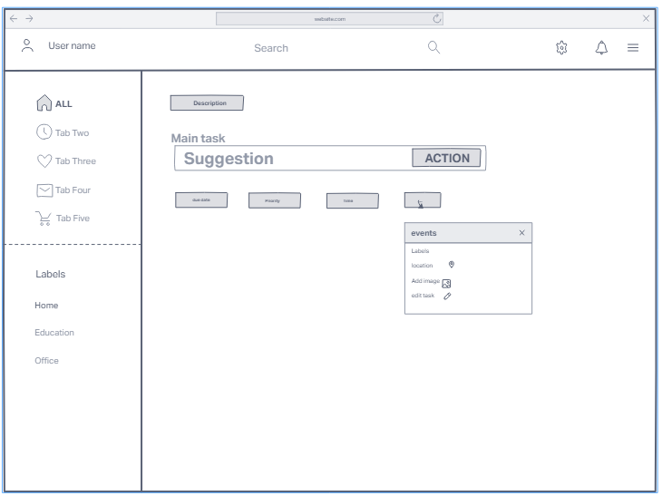
Figure 6: Adding new tasks on the website

In the first model, when adding tasks, the user can prioritise their tasks, add deadlines, locations and add images if required for the task. The user can switch between different labels to view the different tasks that they have (for example: certain tasks may be personal, and others may be for work). They can use a search bar to see whether or not they have added a task, and if they have, which label they may have assigned it to.

7.2 User feedback
A survey was sent out to participants to analyse whether or not participants used productivity applications, and whether or not they were satisfied with their applications. The participants were also encouraged to share why they liked or disliked their productivity applications as well as changes they would want to make to the app. The second model was designed based on the feedback from the participants of the survey.

The survey got results from 20 participants (refer to Appendix 11.3 for the survey results). Around 45% of the participants were not currently using productivity applications. The 55% of the participants that did use productivity apps currently mainly used Google Tasks, Apple To-Do, or Microsoft To-do. Most of the participants stated that the existing productivity applications do fulfil their needs, but wished that the applications were simpler to use and were easy to navigate. They also hoped for ways to be able to share their tasks with friends and send reminders to their friends about getting tasks done on time. By adding that social aspect to future productivity applications, it would be a good way for friends to be able to hold each other accountable to finish their tasks and stay on track with their deadlines and goals.

In general, most of the feedback that the participants had given was already incorporated in the first model of the website. There were a few minor details that were added to the second model to incorporate the participant's needs.

7.3 Second Design
The second model was an adaptation of the first that was created after getting information from users. A survey was conducted where participants were asked if they used productivity apps, and their opinions on them. Based on the results of the survey, changes were made to the first prototype.

In the survey, participants indicated that they would like being able to sync their personal calendar with the application, and a large number of participants indicated that they would like the ability to share tasks with friends, as well as send/receive reminders from friends. As the application cannot sync users personal calendars to the application due to security risks, the users will instead be able to view their tasks in a calendar format. Also, the user will have the option to be able to share their tasks with friends and share their progress with their peers.
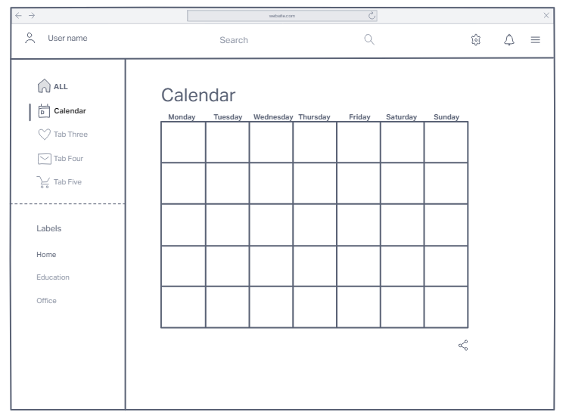
Figure 7: New page in second model design

7.3.1 Second Design - High fidelity
A high-fidelity version of the second design was created. While developing it, we considered making it accessible for all individuals, so we changed the colour scheme of our website.
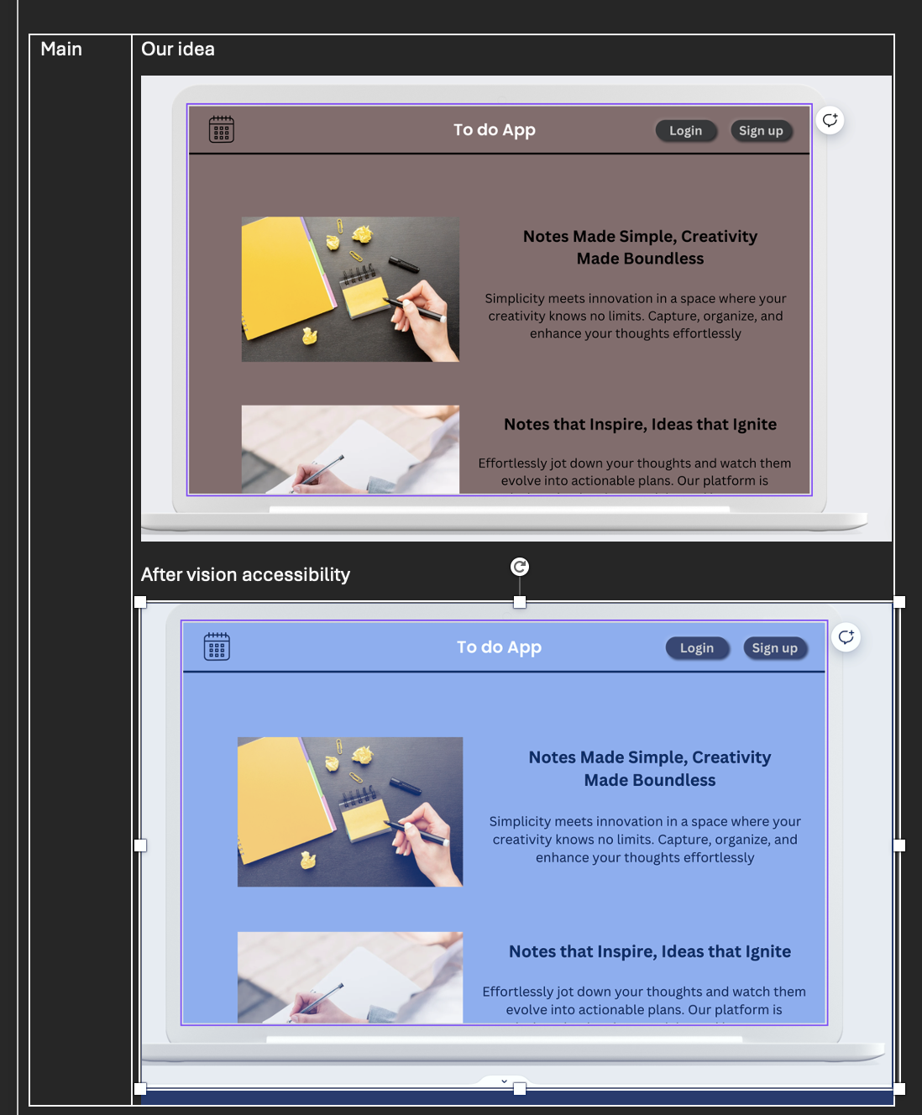
Figure 8: Ensuring the website is accessible for people with visual impairments 1
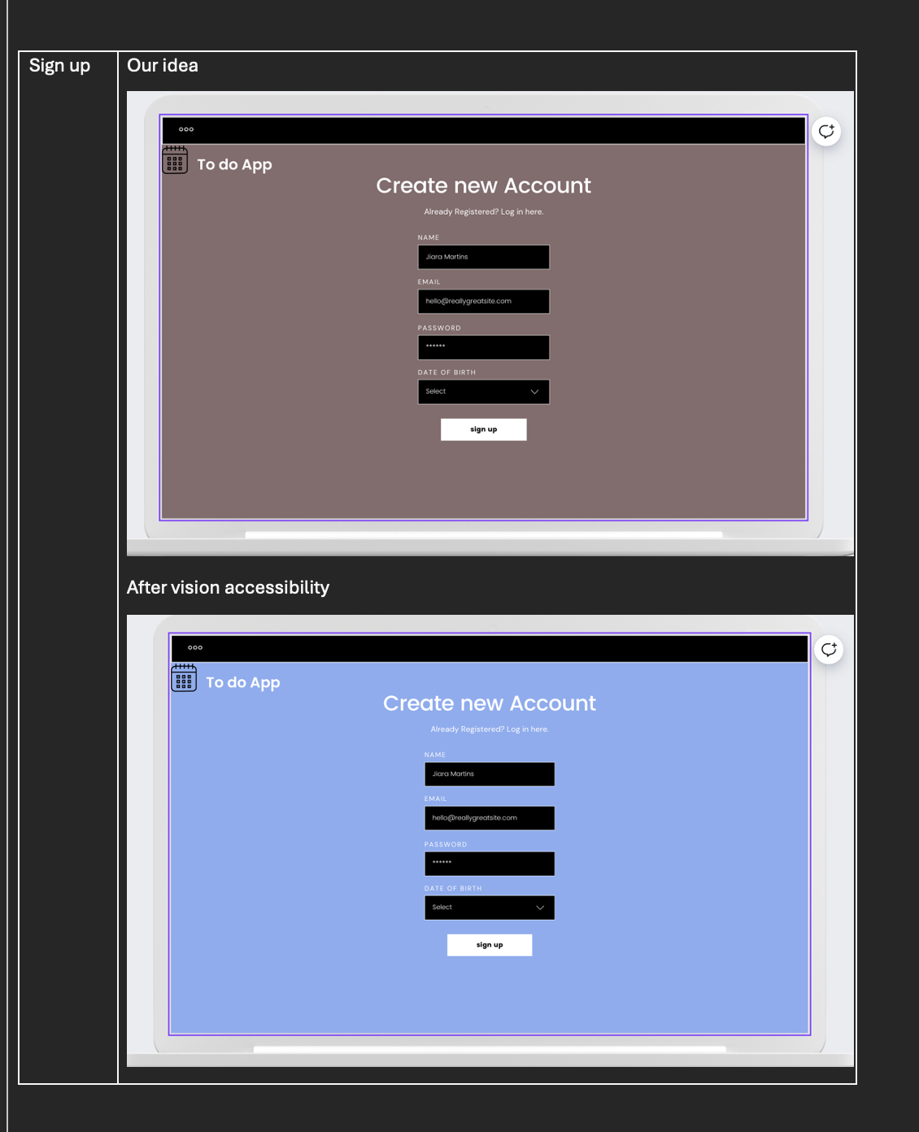
Figure 9: Ensuring the website is accessible for people with visual impairments 2

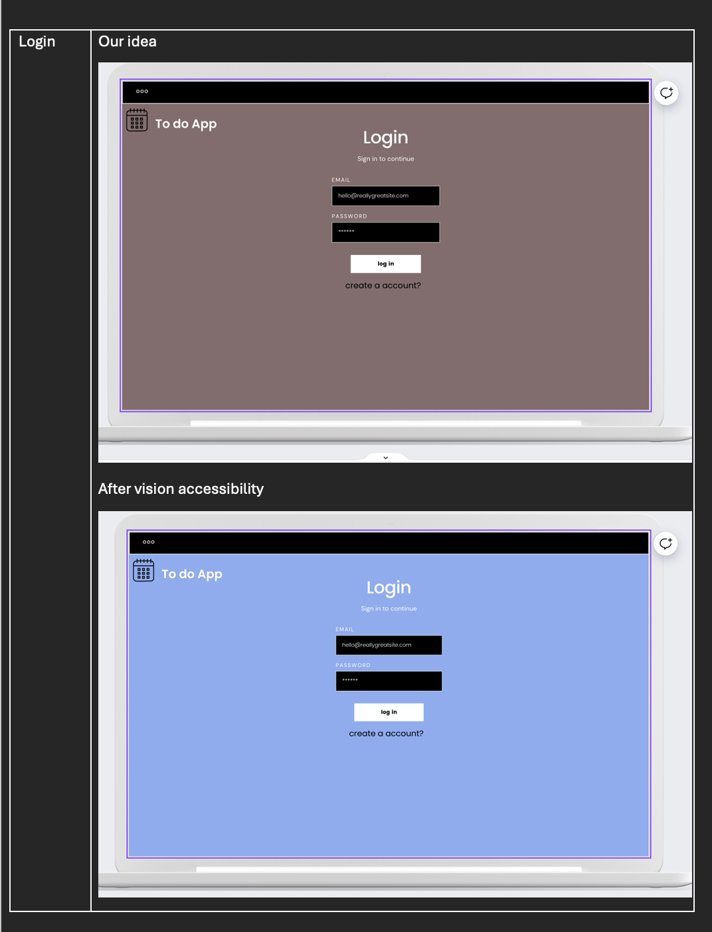
Figure 10: Ensuring the website is accessible for people with visual impairments 3
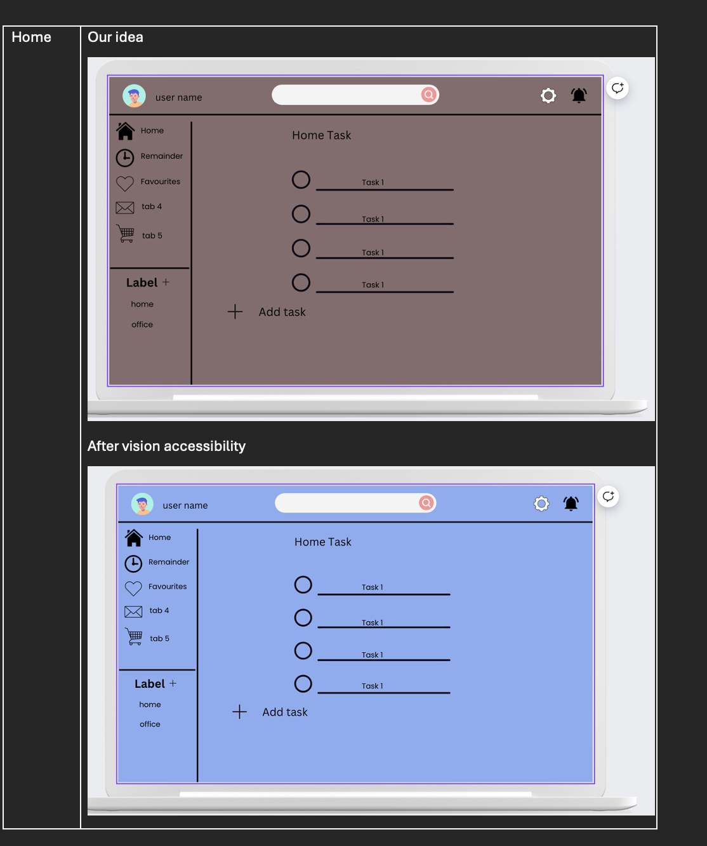
Figure 11: Ensuring the website is accessible for people with visual impairments 4
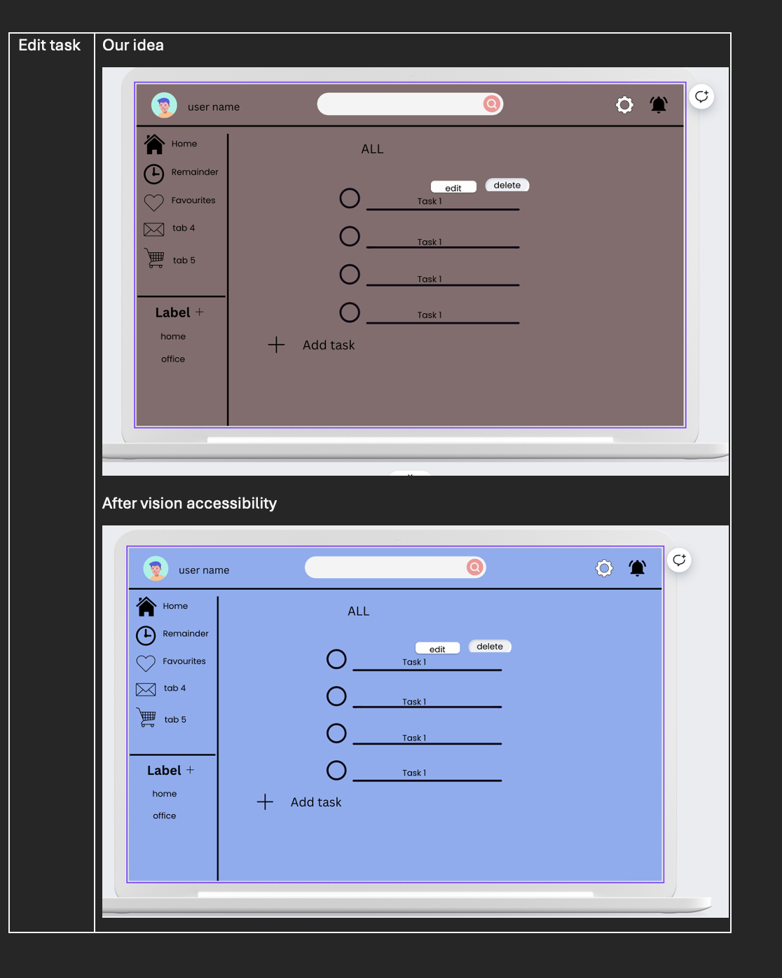
Figure 12: Ensuring the website is accessible for people with visual impairments 5
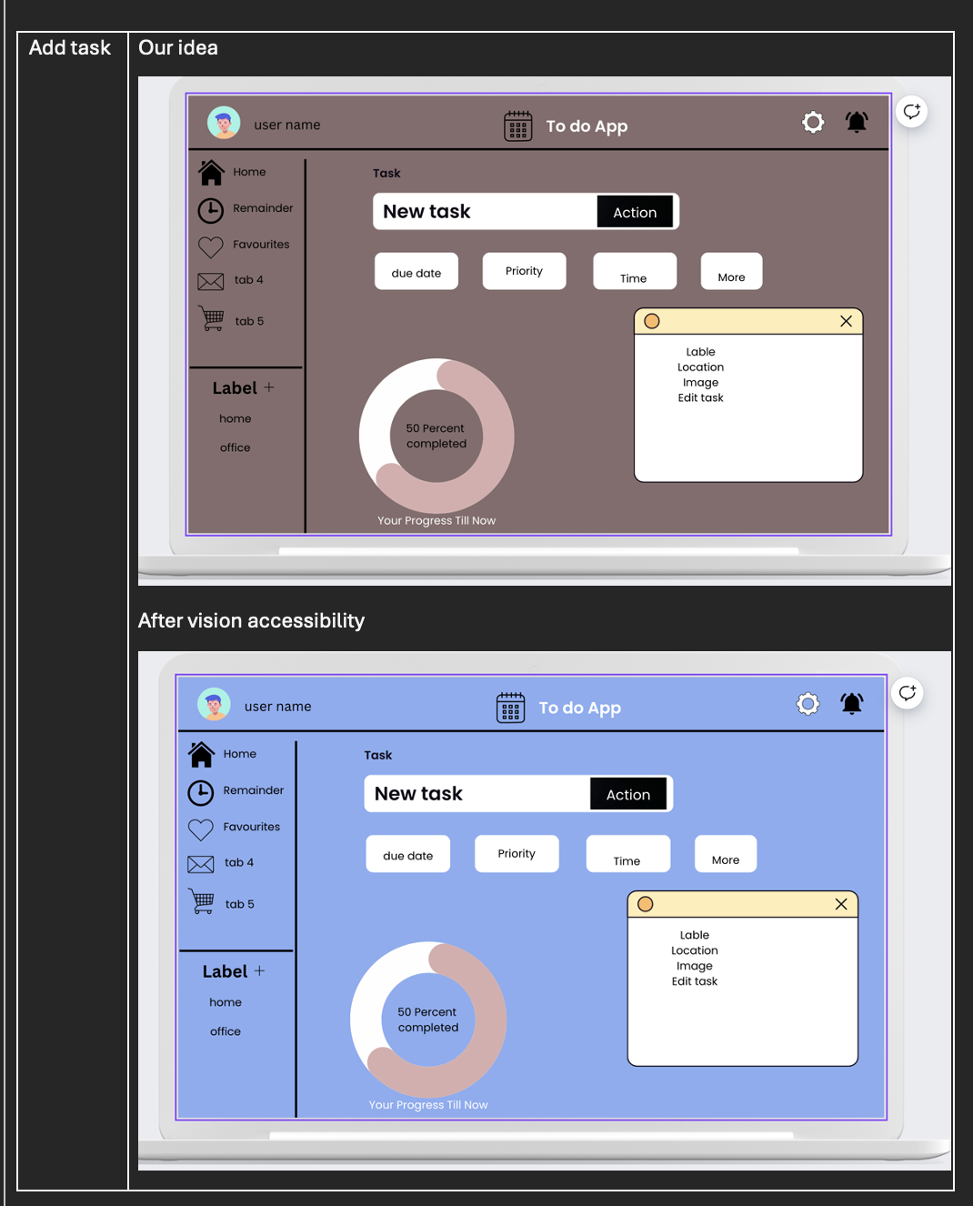
Figure 13: Ensuring the website is accessible for people with visual impairments 6
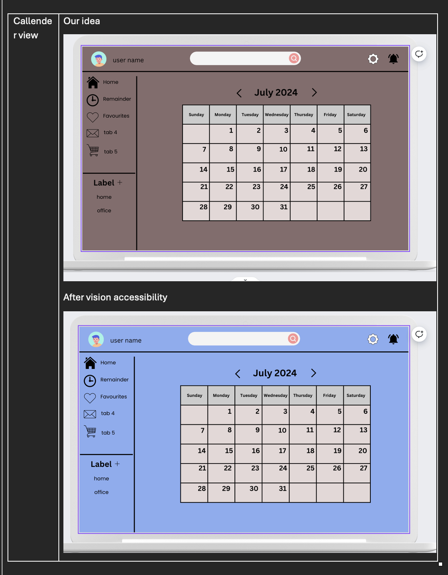
Figure 14: Ensuring the website is accessible for people with visual impairments 7

8. Evaluation and Assumption Testing

8.1 Coming up with the concept
The team’s first meeting consisted of brainstorming various ideas for the project. Multiple ideas were thrown out regarding all kinds of concepts, after which the team discussed which projects were feasible and which were not. For example, the team thought of potentially making an application for an A.I. therapist, but decided that there would be too many legal issues that might arise because of the application. If the A.I therapist were to give bad advice to a potential client, there would be a lot of legal and ethical issues. A large question that would arise is whether or not A.I is capable of helping people with their mental health in this current stage, as it is currently still a work in progress, and whether clients would feel comfortable talking to A.I instead of another person. The team also thought of making a potential social networking site, but realised that the scope of the project would be too big and would not be manageable within the time frame. The team seemed to be the most comfortable with designing a task app or a productivity application for students and working adults instead.
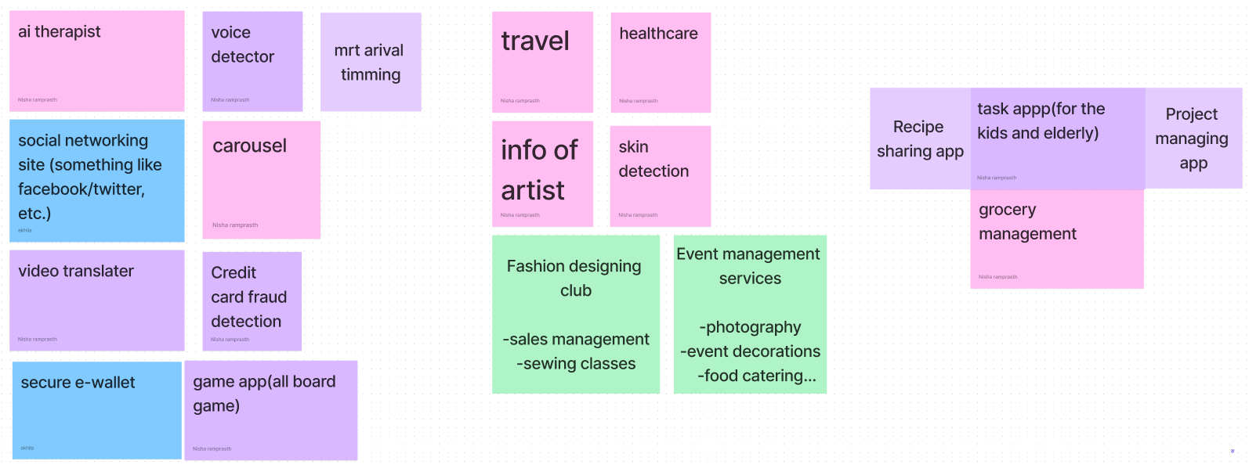
Figure 15: Brainstorming ideas for concept

The image above consists of the ideas the team had come up with. The ideas on the far right are the ideas the team immediately did not want to choose. The middle were ideas the team was comfortable with, and the far right are the ideas that the team kind of went along with (task app and project managing app).

The main issues with a lot of the ideas suggested was that the scope was too big and the project would have been unmanageable, or there would have been some sort of legal or ethical issues with some. The ideas in the middle and the far right were the only ones that seemed to be manageable without being unethical.

8.2 Developing the concept
After the group had decided on a task application, the next idea was to pick what kind of task application the group wanted to create. There were choices between various productivity applications. The group could choose to create an app with timers and gantt charts for project management, or create a to-do list application for people to keep track of tasks. In the end, the team decided to create a to-do list application. They had to think of ways as to why their to-do application would be better than other applications, and they decided that they would want to incorporate a progress bar for tasks because most applications that the team used did not have that, and the team wanted to incorporate a way for the application to be somewhat social. They chose to do so by making the users be able to share certain tasks with their friends. This would help the user’s friends hold the users accountable and ensure that the tasks are getting done.

The concept was further developed by very little to no market research. Maybe deciding on the applications to analyse earlier would have made developing the concept a lot more easier than just randomly thinking of ideas without analysing competitor applications. Analysing competitor applications earlier would have helped determine the base features of our application quicker so we would have more time to think about original features to add.

8.3 Finalising the concept and providing the basis
After the team had chosen the concept for the to-do app and what extra functions they wanted to add, the team then met to discuss which applications to further analyse. The applications chosen were:
- Todoist
- Apple Reminder
- Kidstodo
- Omnifocus
- Google Tasks
- WeNote
The team then split the task and each member chose to analyse one application. During the next meeting, the team came together to discuss the findings on each application and decide what features they liked, they did not like, and what features they would want to improve on. Based on the discussion, the team then chose features that they would like to implement in their application and had a discussion as to why certain features were more important than other features.
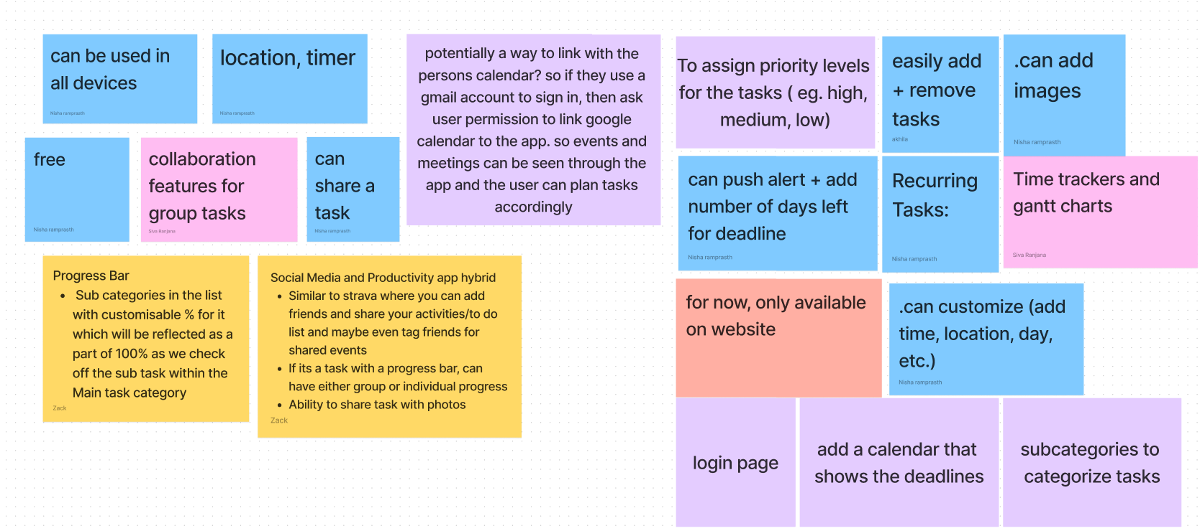
Figure 16: Brainstorming features for To-Do application

The reason why these applications were chosen over others is because these applications are very widely used, and a lot of other to-do list applications are modelled about some of the applications listed above. The only issue is that most of these applications never really specified whether or not they were friendly to users with certain disabilities. For example, it's a bit hard to say whether or not these applications above accommodate for users with visual impairments or users that are colour blind. There may be users with ADHD that may use the applications and they do not mention whether or not certain features have been added keeping other groups of people in mind. The only application that mentions that it caters to users with ADHD and Autism is kidstodo, which is an application specifically catering to children.

8.4 Conducting SWOT and STEEPLE analysis
After analysing and discussing the features we are going to include in this application, We then moved to analyse and discuss the strengths, weaknesses, opportunities and threats pertaining to our application after which we carried out the STEEPLE analysis. Carrying out the SWOT and STEEPLE analysis gives a strategic approach to evaluate internal and external influences on the growth and advertising and marketing of the task management application. These analyses are essential for finding opportunities for development, and expecting potential issues.

Based on the brainstorming about the features to add to our application, our team performed a detailed SWOT and STEEPLE analysis. At this point, key strengths were outlined as including categorisation and sub-tasks functionalities as well as prioritisation and a search feature which all help to organise the tasks of the user. However, the application’s weaknesses were also considered. Some of then are, it had no additional functions, and it was completely dependent on the constant availability of the Internet, which may be problematic in some regions. Regarding the opportunities, it was evident that users expect more functionalities such as integrated collaboration tools and real-time updates; additionally, there is a possibility to address the issue of limited access by creating a mobile application in the future. On the other hand, we identified major risks in terms of competition from Microsoft To Do and Todoist and threats of data insecurity. These findings are going to be particularly helpful as we define the plan of action with regard to the app and the risks involved.

While the SWOT analysis focused on internal strengths, weaknesses, opportunities, and threats, we did STEEPLE analysis to get a deeper understanding on external factors impacting our app's success. In the social aspect, the increased adoption of digital tools to maintain schedules and productivity throughout user lives creates a great context for our app; thus, the importance of integrating various features and the frequent analysis of users’ preferences to guarantee the continual update and efficiency of our app. From the technological viewpoint, the high penetration rate of mobile devices like smartphones and tablets makes the environment favourable for our app to appeal to a wide population base while integrating our app with other tools via APIs and other external tools which provide additional benefits in the usability of the app. In the economic aspect, the optimization of work processes and enhancing efficiency hold definite advantages for business entities. In this way, environmentally, our application provides an efficient way to decrease the usage of paper for important tasks and encourage environmentally friendly actions due to scheduling tasks remotely. From a political and legal perspective, the use of data protection laws such as the GDPR is now a regulatory standard that needs to be followed to ensure compliance and users’ trust. Policies on data protection and privacy regulation as well as covering proprietary rights also act as ethical displays while biomedical technology should be free from over-commercialization and improper use policies which greatly increases its credibility with users. Through the STEEPLE analysis above, we get the following on how to approach the external environment to ensure that the application meets market needs and standards as well as legal provisions.

8.5 Model design
The initial model design was created based on the features that the team wanted to implement in the application. The design was an amalgamation of the features, as well as the layouts of the different applications that were analysed. The second model was based on the user feedback from user testing.

One of the biggest issues with the model design is the fact that the users could not give feedback on the first model itself. The feedback that the users gave was on their personal experience with productivity applications. The main reason why there was no user feedback on the first model design was because it wasn’t a working model that participants could test. Hence the second model was made based on their critique on other productivity applications.

8.6 Assumption Testing
Some initial assumption we had regarding an effective productivity app:

1. User-Centred Design
- User Needs: Assume that users need a simple, intuitive interface that allows them to manage their tasks efficiently.
- Customization: Users want the ability to customise the app to fit their unique workflows and preferences.

2. Core Functionality
- Task Management: Users need robust task management features, including task creation, assignment, deadlines, prioritisation, and status tracking.
- Calendar Integration: Integration with popular calendar apps to manage deadlines and reminders.
- Collaboration Tools: Users need features for team collaboration, such as shared task lists, comments, file attachments, and real-time updates.
- Ease of Use: The app should be easy to navigate, with a clean and uncluttered interface.

3. Performance
- Speed and Reliability: The app must be fast and reliable, with minimal downtime and quick response times.
- Offline Access: Assume that users may need to access their tasks and data offline, so offline capabilities should be considered.
From our user feedback survey, there isn’t a common app that users tend towards. This suggests that the functionality of the existing apps are rather similar and there isn’t a strong differentiating point for users to choose one over the other. However, among those who use a task management app, up to 35% of them felt that the current apps they use were unsatisfactory and couldn’t properly fulfil their needs. Among those surveyed, they suggested things like, an interactive design, timely reminders and methods to help increase workflow efficiency. These are some of the features that users believed will better attract them to use the productivity app.

In addition, many users believed that having a social aspect to the task management app would enhance the overall experience for the app. Up to 80% of those surveyed said that they would like the ability to share their tasks with friends.

8.7 General Evaluation
In order to create an effective task management and productivity app for students involves several critical stages, from concept development and competitive analysis to assumption testing and user feedback integration. Some of our key takeaways include the importance of thorough market research, addressing accessibility and inclusivity, and continuously refining the product based on user feedback and strategic analysis. By focusing on unique features like progress tracking and social sharing, we can develop an app that stands out in a crowded market and meets the specific needs of students.

9. Conclusion
In today's fast-paced world, effective task management is crucial for maintaining productivity and organisation. A well-designed todo app can significantly enhance the user's ability to manage tasks, set priorities, and achieve goals efficiently. Through careful evaluation of existing task management applications like Todoist, Apple Reminders, KidsTODOList, and Google Tasks, we have identified key strengths and areas for improvement that inform our proposal for a new, innovative todo app.
Our proposed todo app aims to integrate the best features of these existing applications while addressing their weaknesses to provide a superior user experience. Key features of our app will include:
- Intuitive User Interface: A clean, user-friendly design that makes task management effortless.
- Cross-Platform Sync: Seamless synchronisation across all devices to ensure users can access their tasks anytime, anywhere.
- Advanced Task Management: Features like sub-tasks, due dates, reminders, and prioritisation to cater to complex task management needs.
- Customizable Workflows: Flexibility to adapt the app to individual users' workflows and preferences.
By combining these features, our todo app will stand out in the market as a comprehensive, user-centric solution for task management. We are confident that this approach will not only meet the needs of a wide range of users but also foster increased productivity and satisfaction. We look forward to bringing this vision to life and helping users everywhere manage their tasks more effectively.

10. References
(n.d.). A simple to do list for you and your team. Retrieved July 6, 2024, from https://www.any.do
Docker. (n.d.). Docker: Accelerated Container Application Development. Retrieved July 6, 2024, from https://www.docker.com
Express. (n.d.). Express - Node.js web application framework. Retrieved July 6, 2024, from https://expressjs.com
Features. (n.d.). Todoist. Retrieved July 6, 2024, from https://todoist.com/features
Github. (n.d.). GitHub: Let's build from here · GitHub. Retrieved July 6, 2024, from https://github.com
Google Tasks – Apps on Google Play. (n.d.). Google Play. Retrieved July 6, 2024, from https://play.google.com/store/apps/details?id=com.google.android.apps.tasks&hl=en_SG
Kids ToDo List - LITALICO Apps. (n.d.). litalico. Retrieved July 6, 2024, from https://app.litalico.com/kidstodolist/index.html
MongoDB: Loved by developers. (n.d.). MongoDB: The Developer Data Platform | MongoDB. Retrieved July 6, 2024, from https://www.mongodb.com
Production-Grade Container Orchestration. (n.d.). Kubernetes.io. Retrieved July 6, 2024, from https://kubernetes.io
React: The library for web and native user interfaces. (n.d.). React. Retrieved July 6, 2024, from https://react.dev
Reminders on the App Store. (n.d.). App Store. Retrieved July 6, 2024, from https://apps.apple.com/us/app/reminders/id1108187841
Run JavaScript Everywhere. (n.d.). Node.js — Run JavaScript Everywhere. Retrieved July 6, 2024, from https://nodejs.org/en
Start building on AWS today. (n.d.). Cloud Computing Services - Amazon Web Services (AWS). Retrieved July 6, 2024, from https://aws.amazon.com
Task Management Software Built For Pros - OmniFocus. (n.d.). The Omni Group. Retrieved July 6, 2024, from https://www.omnigroup.com/omnifocus/
WeNote: Notes, To-do, Calendar. (n.d.). Best notebook app. Retrieved July 6, 2024, from https://www.wenote.me

11. Appendices

11.1 Appendix: Notes and ideas from meetings

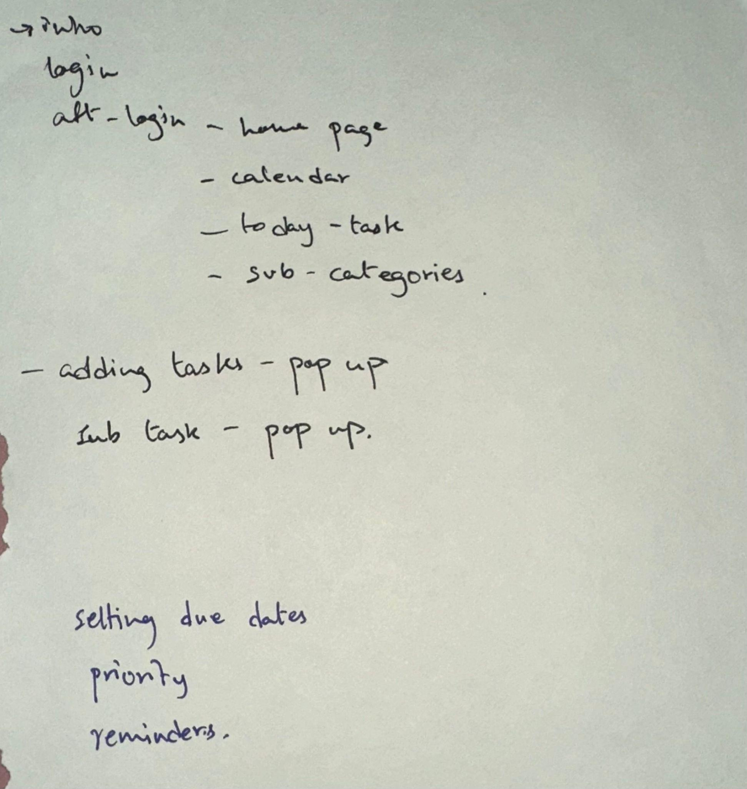
- Discussing the webpages for our website
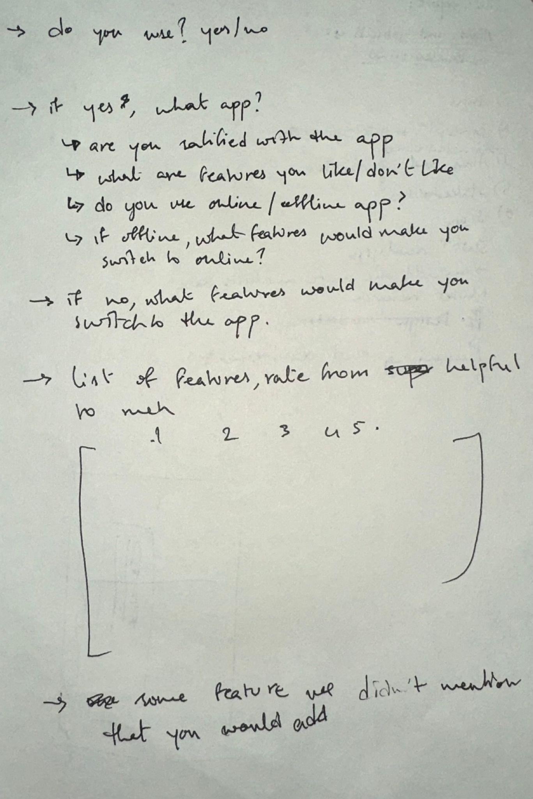
- Thinking of questions for the survey
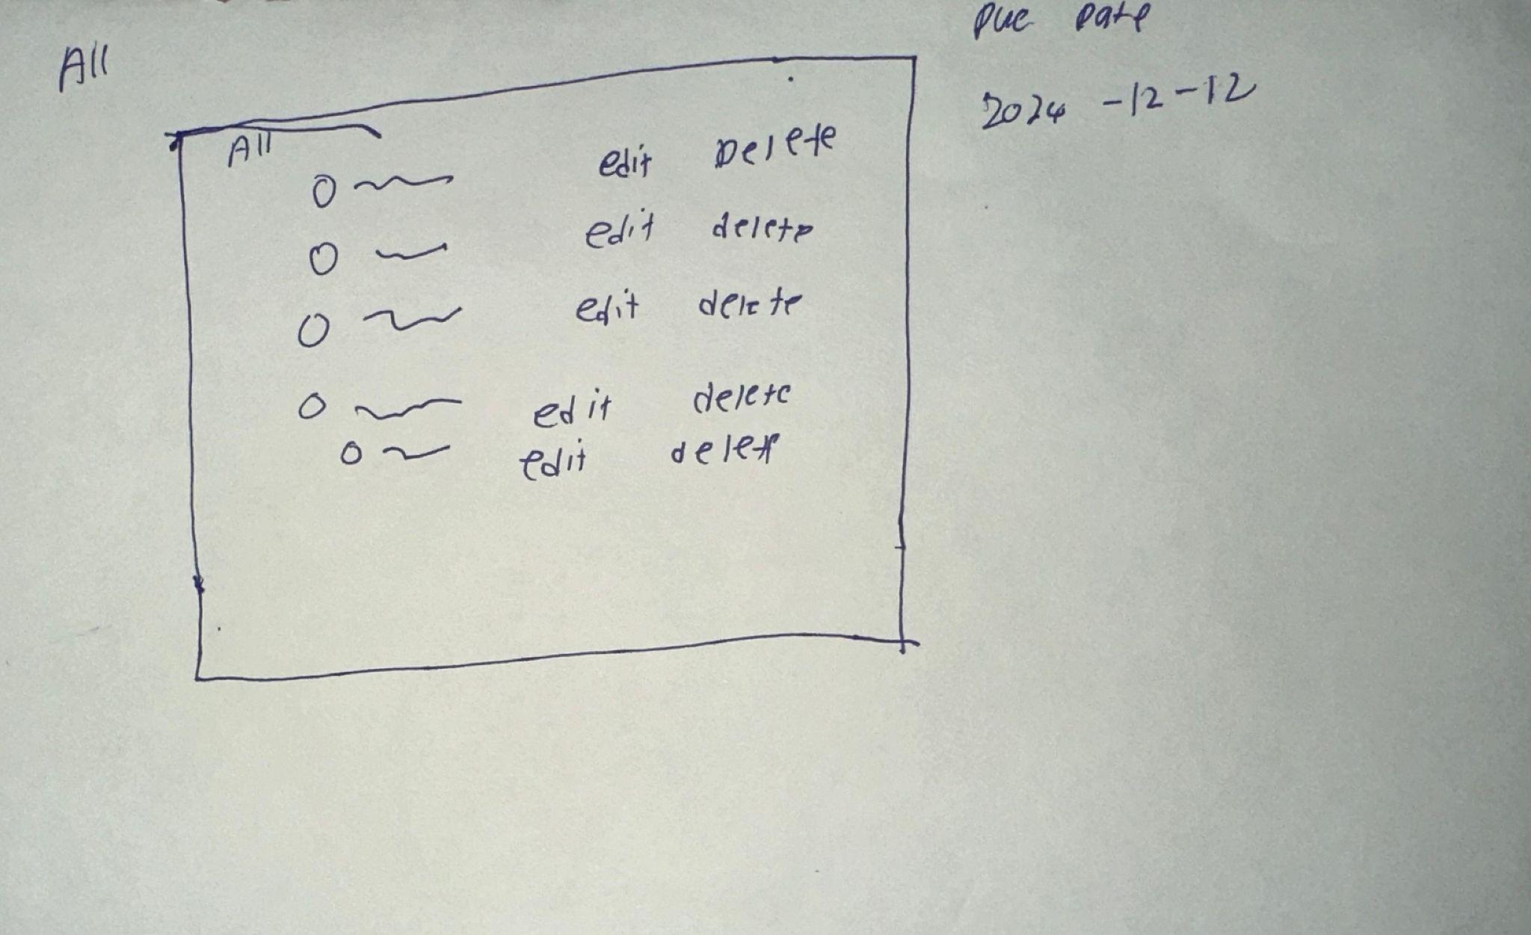
(c) Ideas for website 1
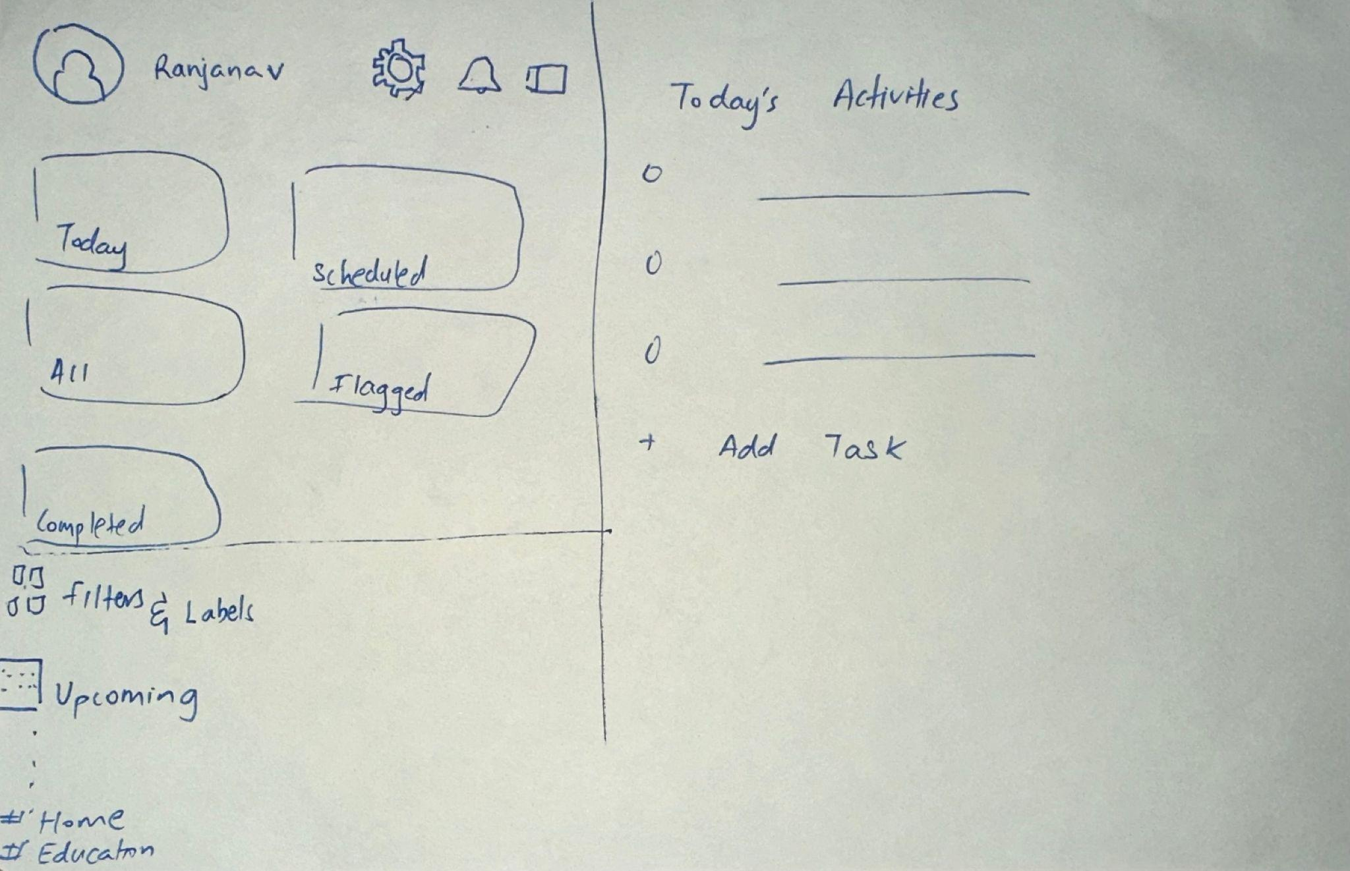
(d) Ideas for website 2
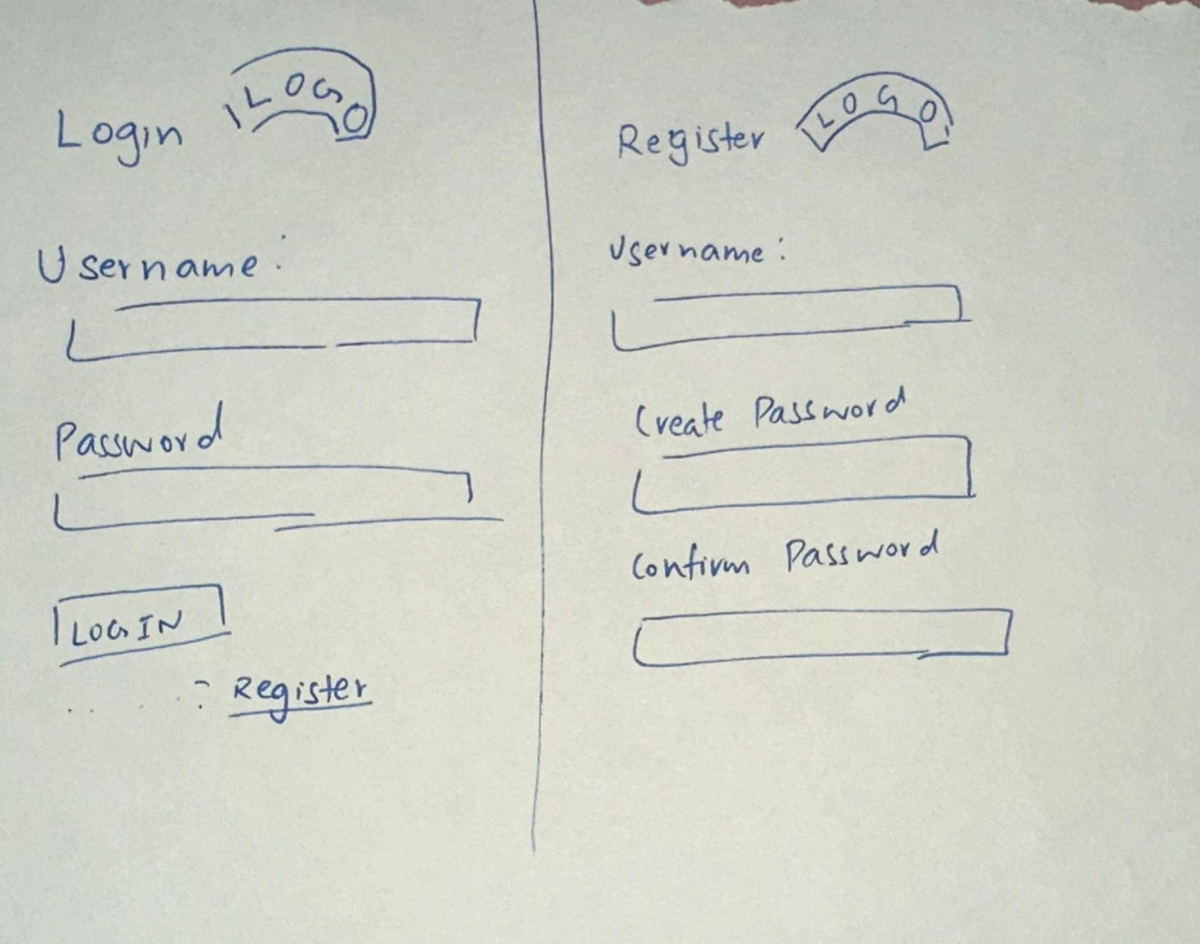
(e) Ideas for website 3
(f) Ideas for website 4

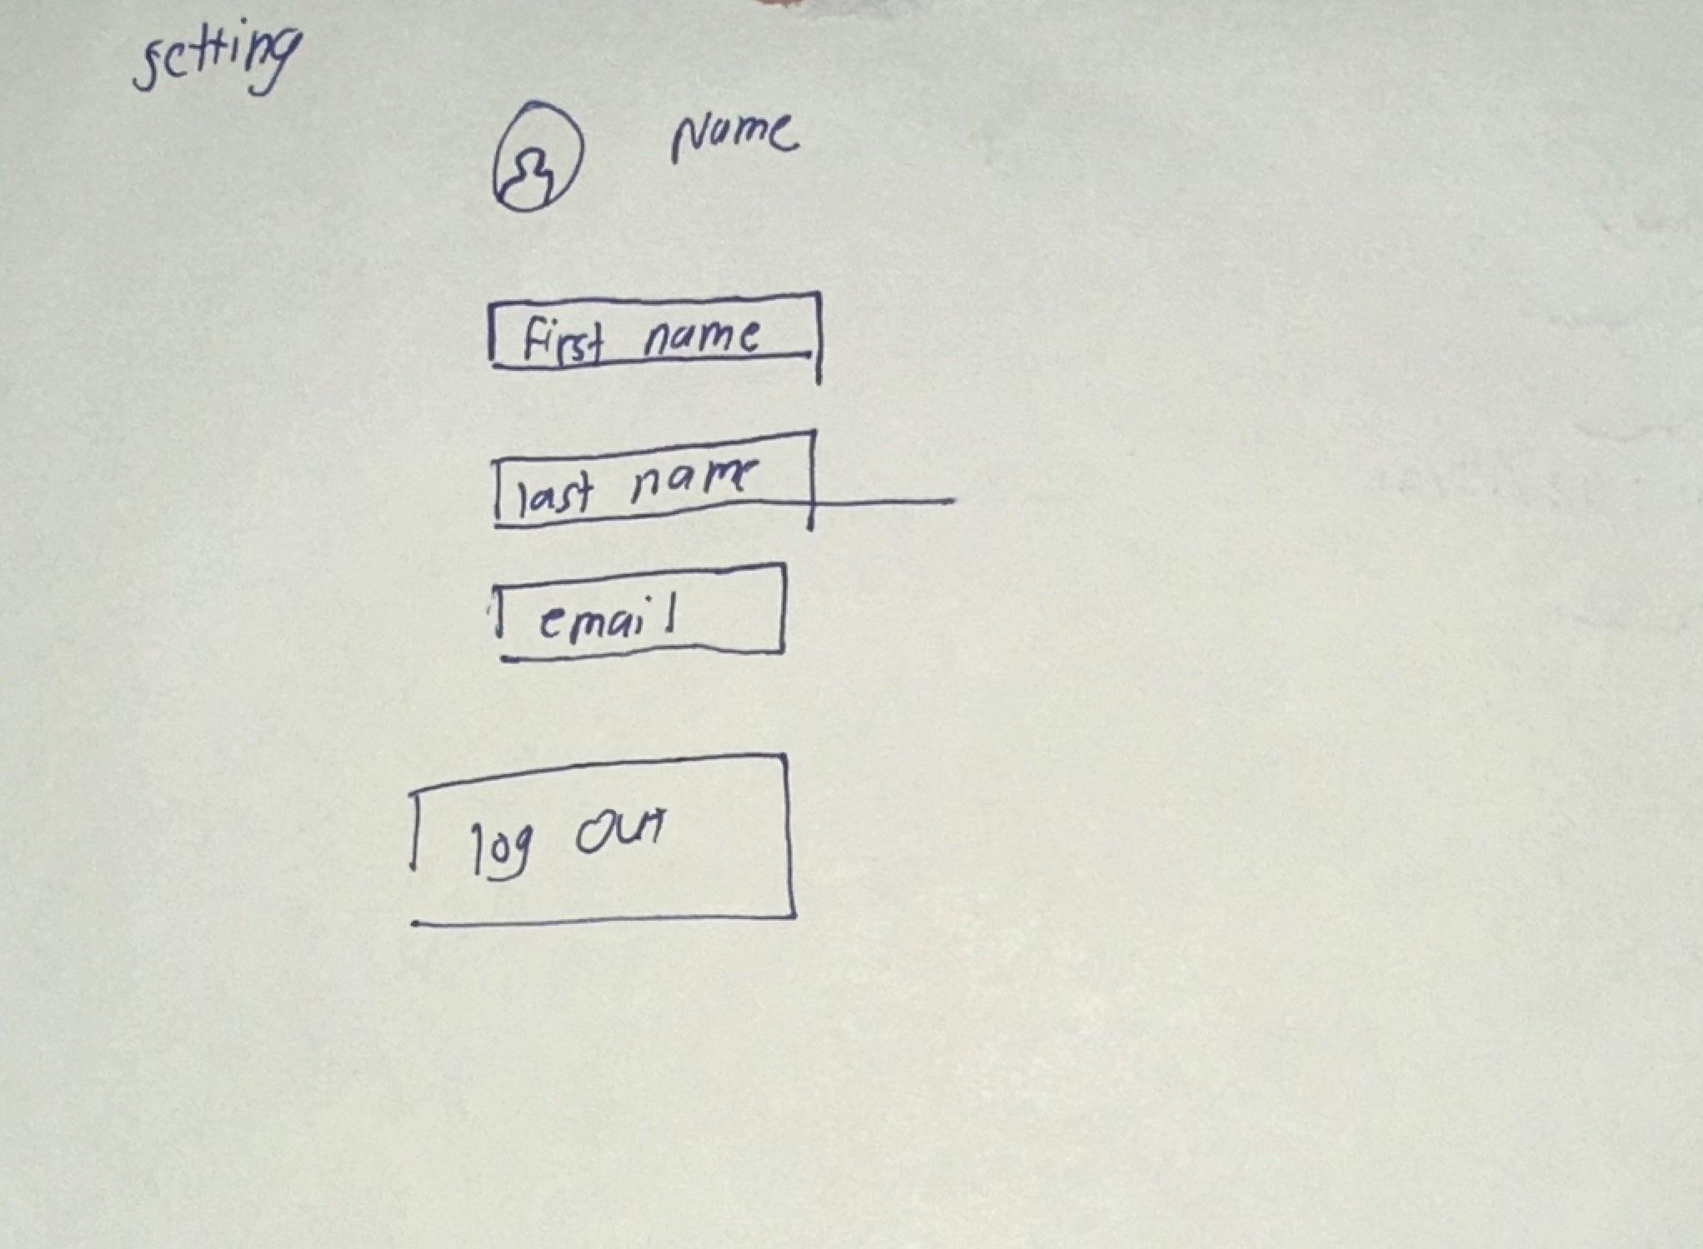
(g) Ideas for website 5

11.2 Appendix: First design model
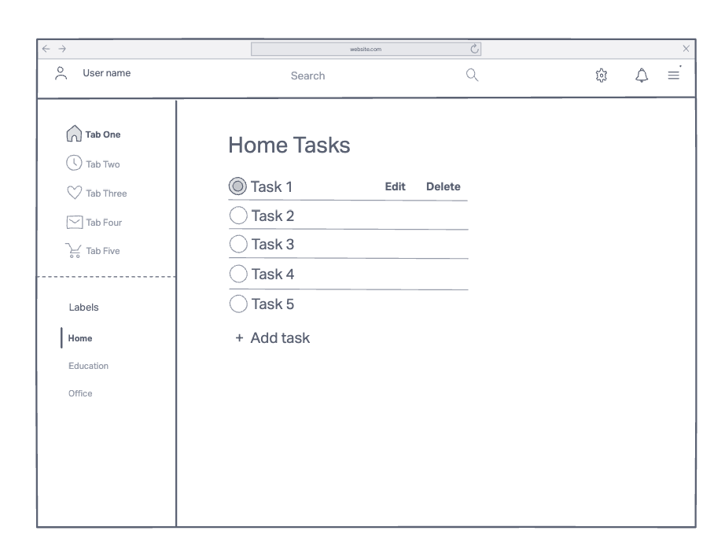
(a)Home page
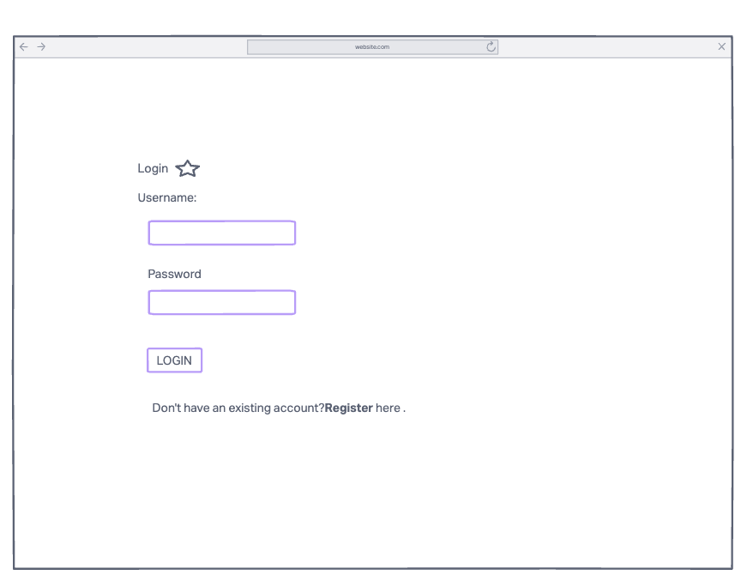
(b)login

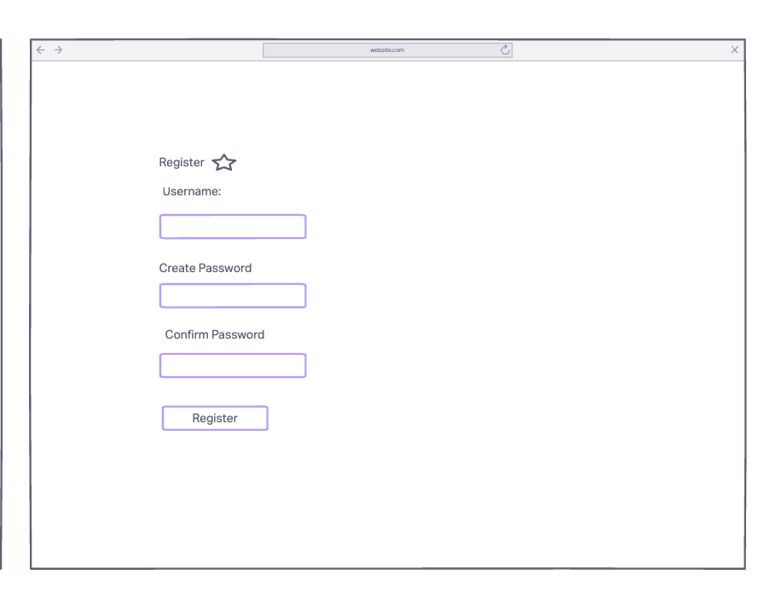
(c)register
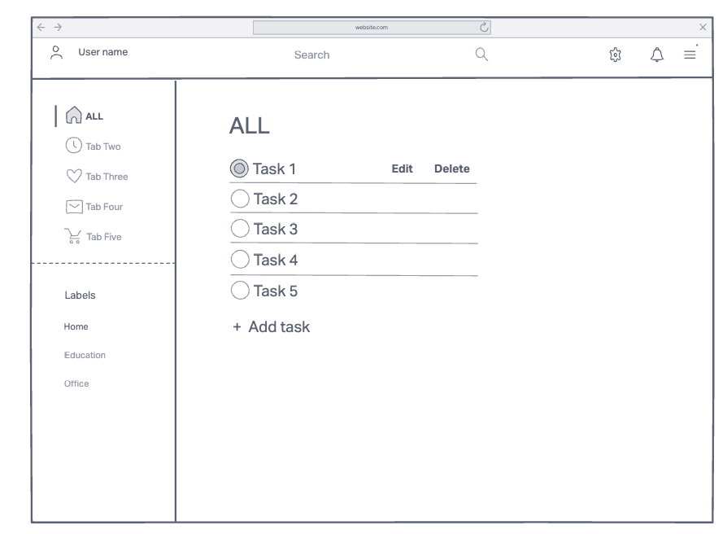
(d)edit task
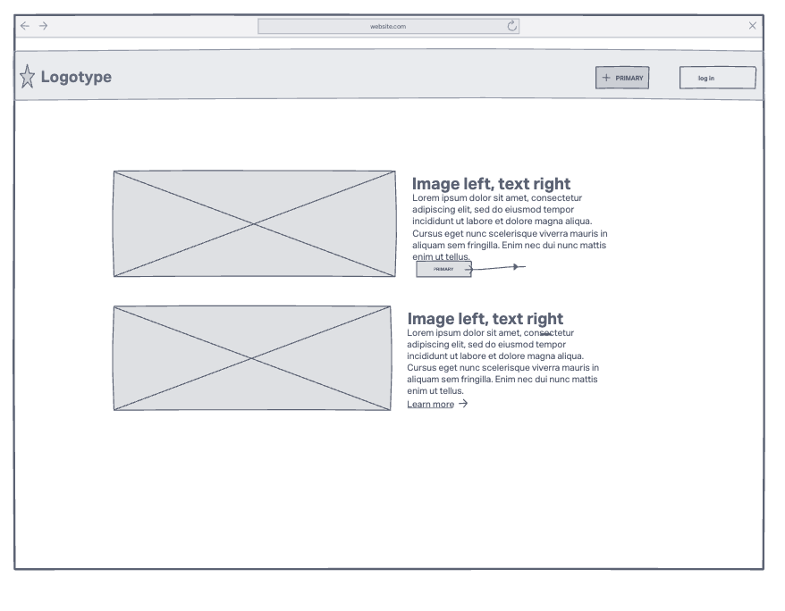
(e) introduction page
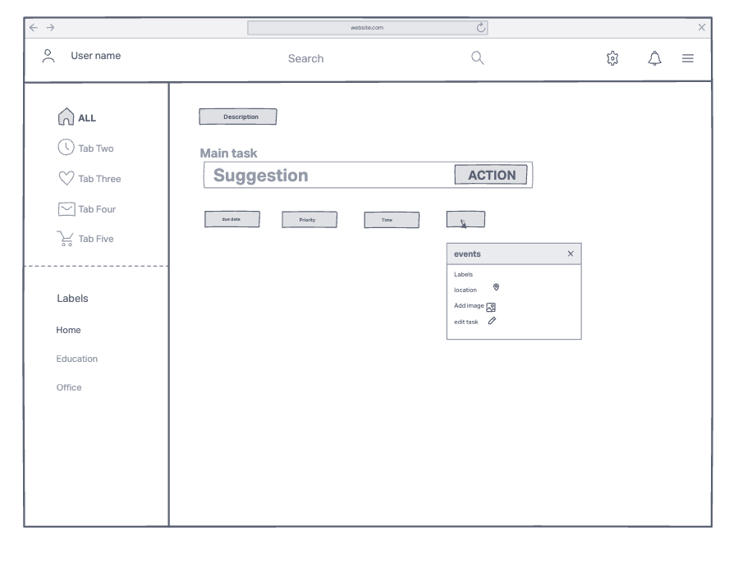(f)add task

11.3 Appendix: User feedback
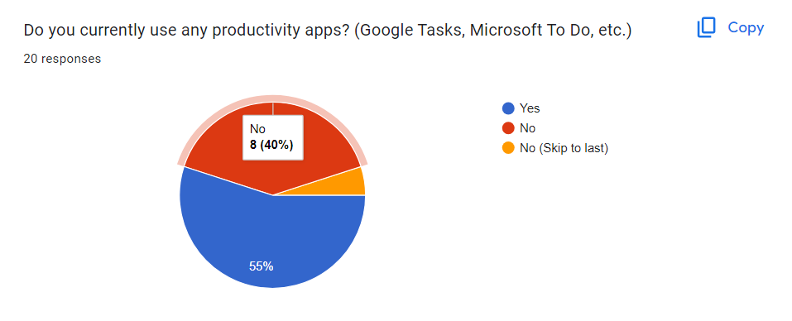
- Survey results - question 1

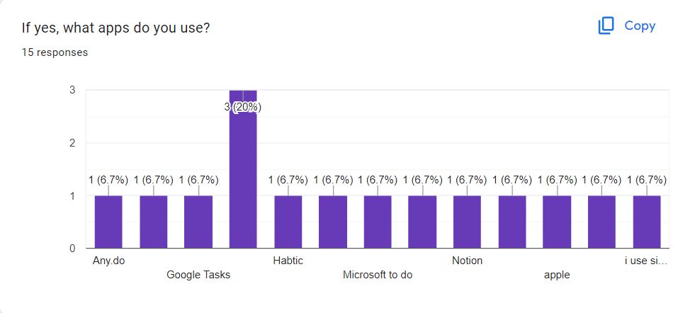
- Survey results - question 2
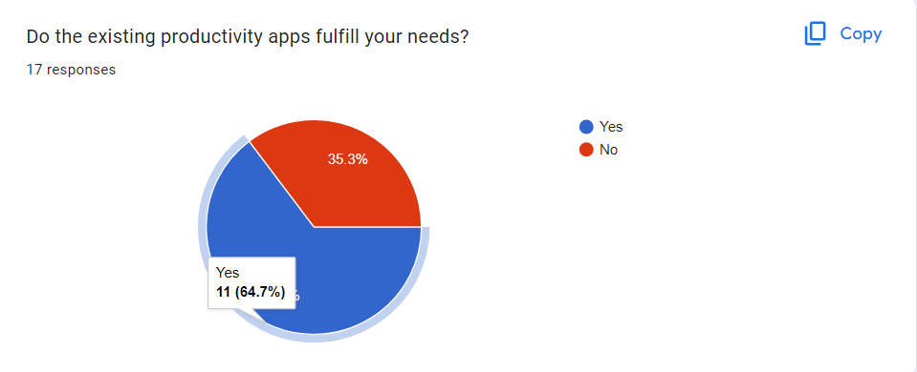
- Survey results - question 3
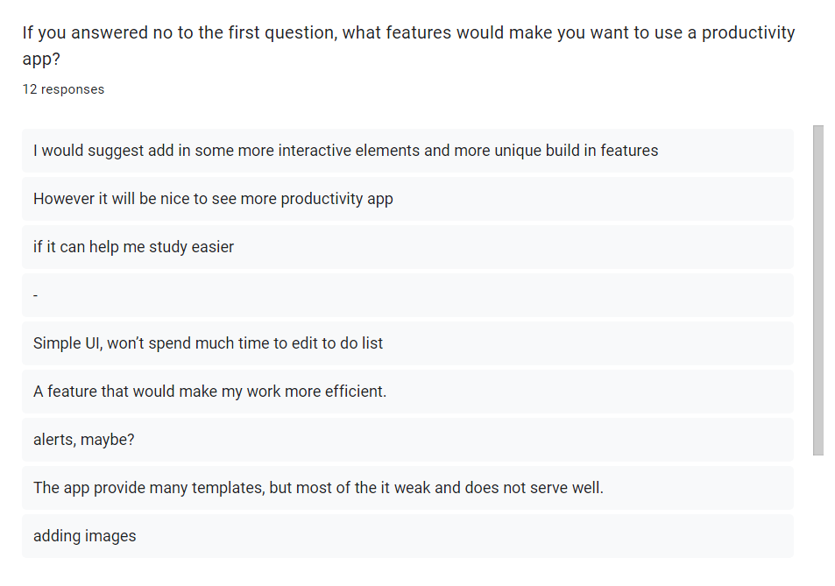
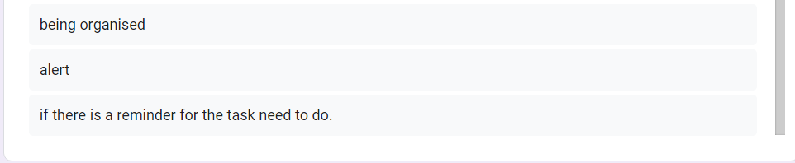
- Survey results - question 4
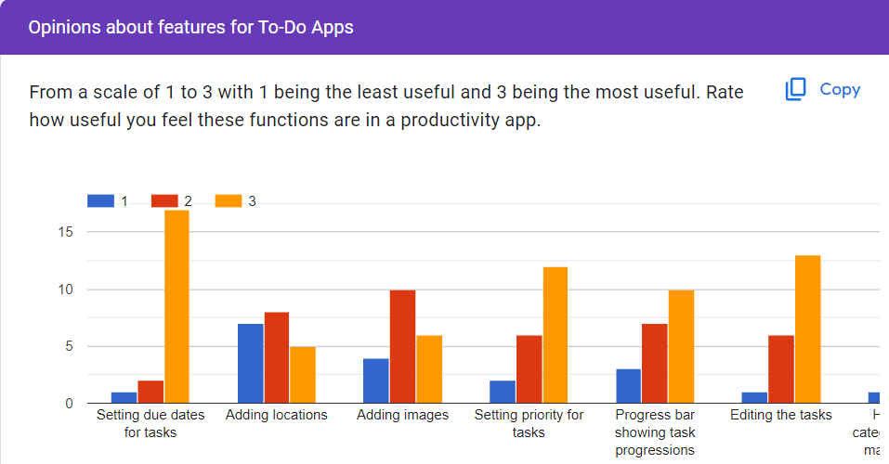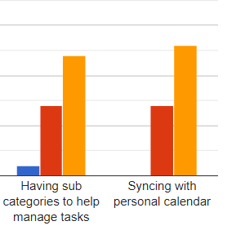
(e)Survey results - question 5

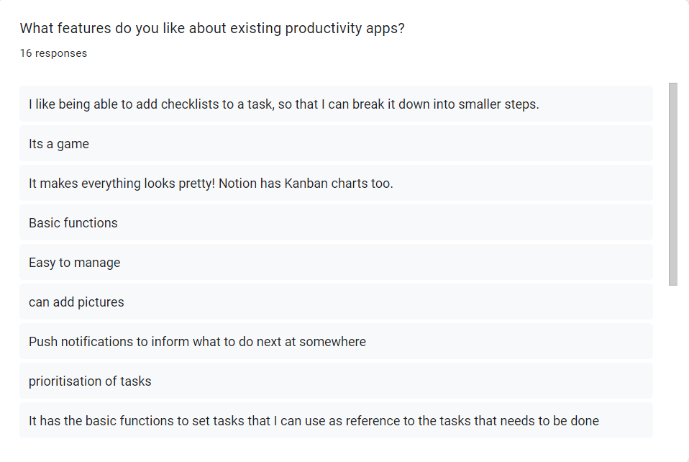
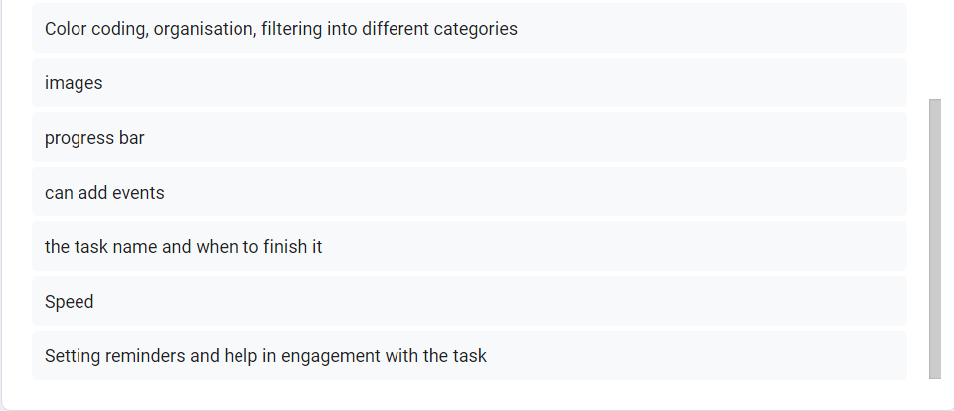
(f)Survey results - question 6

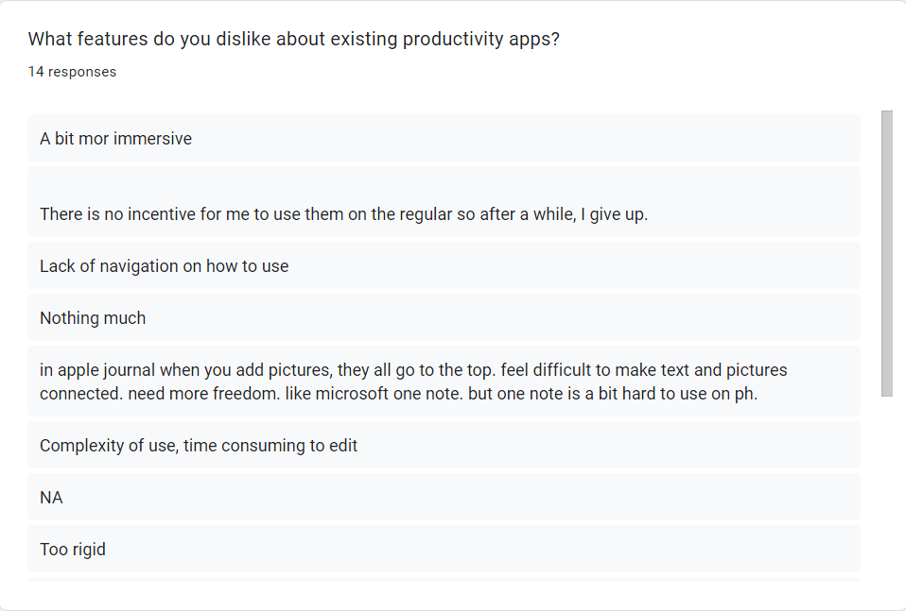
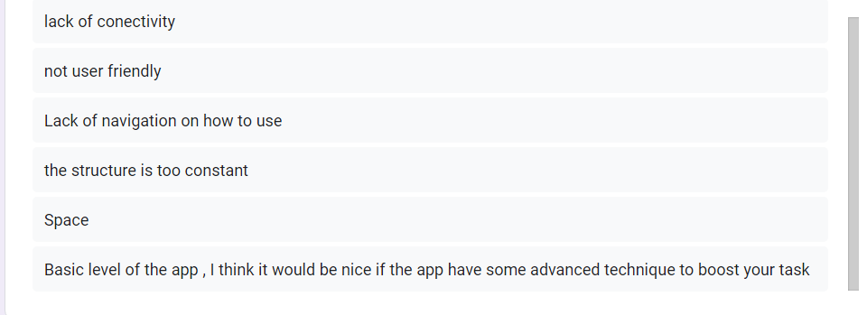
(g)Survey results - question 7

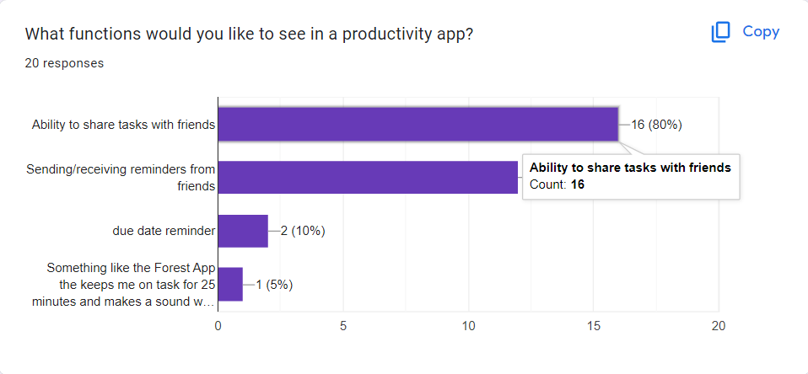
(h)Survey results - question 8

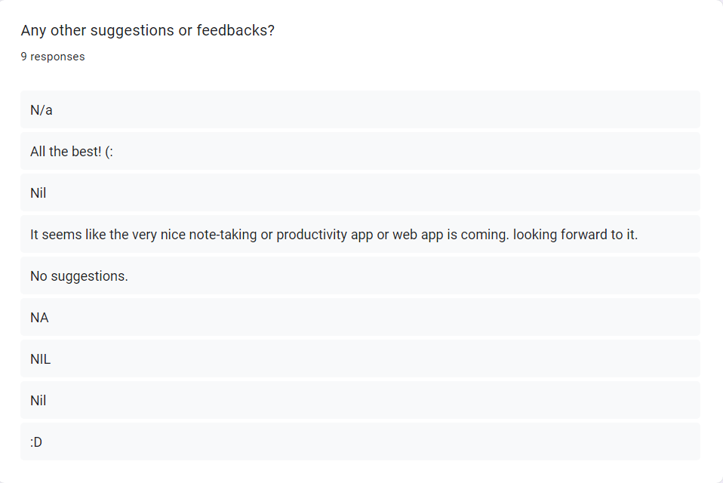
(i)Survey results - question 9

(React: The Library for Web and Native User Interfaces, n.d.)
(Run JavaScript Everywhere, n.d.)
(Express, n.d.)
(MongoDB: Loved by Developers., n.d.)
(Github, n.d.)
(Docker, n.d.)
(Production-Grade Container Orchestration, n.d.)
(Start Building on AWS Today, n.d.)
(Features, n.d.)
(Reminders on the App Store, n.d.)
(Kids ToDo List - LITALICO Apps, n.d.)
(Task Management Software Built For Pros - OmniFocus, n.d.)
(Google Tasks – Apps on Google Play, n.d.)
(WeNote: Notes, To-Do, Calendar, n.d.)

